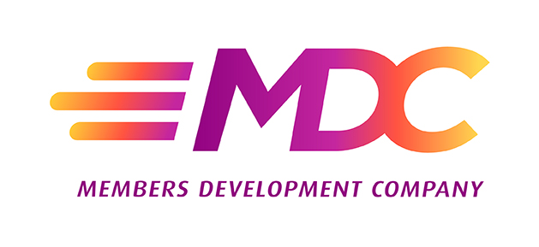

**For Immediate Release**

**Members Development Company Adds Staff, Responding to**

**Recent Ownership Growth**

***R&D CUSO positions itself for enhanced value to owners***

**Madison, WI (February 2, 2021)** – In the past three years, Members Development Company (MDC), a network of forward-thinking credit unions and CUSOs, has grown from 40 to around 70 owners. The goal was not simply to grow but to work with the right partners, i.e., ones that share the same enthusiasm for strengthening the cooperative movement. As a reflection of the growth and MDC’s commitment to working closely with its owners, the Company announced the hiring of three additional staff members: **Tushar Mukhija** as the new Director of Strategic Partnerships, **Michelle Mozzar** as the Senior Project Manager and **Nancy Hragyil** as the Executive Assistant.

MDC focuses on working with experts within and outside the credit union industry, as well as its owner credit unions, to develop relevant and workable solutions to challenges facing the industry. “Our history has shown our commitment to working together to provide value to our owners,” said Jeff Kline, CEO. “I'm excited to have such experienced, committed people joining our staff so we can continue to provide the high level of support and benefits to our owners as we move forward.”

Tushar Mukhija was hired as the Director of Strategic Partnerships. As such, he is responsible for maintaining and enriching MDC’s relationships both with the CUSO’s owners as well as third-party partners. Mukhija has an extensive history in account and vendor management, working with large companies across a variety of industries, including Gartner. A native of Pennsylvania, he earned a Bachelor of Science in Business Administration with a concentration in International Business Management and a minor in Economics from Kings College in Pennsylvania.

“The opportunity to work with others so that our shared ideas and experiences can strengthen the credit union industry is what attracted me to MDC,” said Mukhija. “I welcome the chance to learn from industry leaders as I support our owners.”

Responsible for enhancing MDC’s project portfolio, Michelle Mozzaris the Senior Project Manager. She has 20 years of experience in the financial services industry, including time at Wells Fargo. Her previous responsibilities have included leadership positions in strategic planning, change management, leadership development, training and operations. She holds a doctoral degree in Interdisciplinary Leadership from Creighton University in Nebraska.

“MDC has a reputation as a leader in innovative ideas to strengthen the industry,” said Mozzar. “I'm thrilled to be able to collaborate with industry experts and thought leaders, as well as our credit union owners.”

Hired in November 2020, Nancy Hragyil is the Executive Assistant. Raised in a military family, she learned the value of hard work and efficiency at an early age. In her career, she has worked in various industries, sharpening her skills and earning promotions for her ability to streamline processes and get results. She now supports MDC’s executive staff by handling multiple diverse concerns.

“Finding ways to increase efficiency and effectiveness is what I love to do most,” Hragyil said. “I look forward to working with MDC and our owners to create a stronger credit union community.”

MDC’s strategy is to identify areas in which it can make a significant impact on its owners and their members. With the recent hiring, the company is now fully staffed to implement its strategic plan. In addition to Kline and the new staff additions, MDC’s team members are: Sarah Lietz, Chief Experience Officer; Kristen Jones, VP, Finance and Operations; Michael El Koubi, Marketing and Communications Manager; and Megan Hildebrandt, Meeting and Event Planner.

"The addition of MDC's new staff members puts us in a powerful position to be able to capitalize on our substantial growth in recent years," said Amy Sink, CEO of Interra Credit Union and MDC's Board Chair. "MDC has ambitious plans that will help credit unions compete in the industry, and it is well-positioned to execute those plans."

###

Members Development Company is an interactive and future-focused network leading credit unions through collaborative innovation, development, thought leadership, and research. Combined, our owners serve 16.4 million members, hold over $271.7 billion in assets, maintain over 1,900 branch locations across the nation and employ more than 42,000 credit union professionals. MDC’s vision is to be *the* collaborative force accelerating credit union success. More information is available at [www.membersdevelopment.com](http://www.membersdevelopment.com/).

**Contact**

Cheryl Johnson

913.488.2710

[cheryl.johnson.pr@gmail.com](mailto:margaret@mjbpr.com)