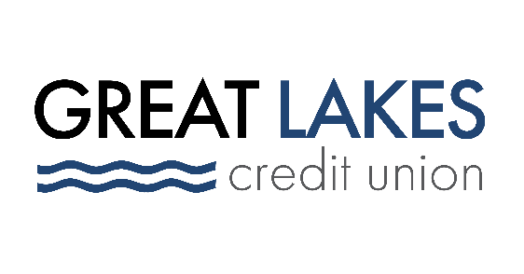

www.glcu.org
FOR IMMEDIATE RELEASE | Contact: Media Department  media@glcu.org  (847) 578-7324
Great Lakes Credit Union Commemorating Dr. Martin Luther King Jr.
by Virtually Reading to the Youth

BANNOCKBURN, IL (Jan. 11, 2022) - Great Lakes Credit Union (GLCU) is kicking off the New Year by volunteering at West Elementary School in Zion, IL, to read books to students about Rev. Dr. Martin Luther King Jr. The chosen books will highlight MLK’s work on equity, diversity and civil rights.

On Tuesday, Jan. 18, from 9 a.m. to 10 a.m. and 12:30 p.m. to 1:30 p.m., GLCU will provide a total of 16 volunteers, two of which will be reading in Spanish to make sure everyone has an equal opportunity to learn. Approximately 300 to 350 children from third through fifth grades will be present at the readings.

By partnering with United Way of Lake County to support the virtual event, GLCU can safely serve the community and provide support on literacy to young students despite the COVID-19 pandemic.

"We understand that during this difficult time not all students have easy access to books at home,” said Abraham Santiago, Senior Manager of Community and Financial Education programs. “Through our partnership with United Way of Lake County, we are excited to not only read to the children virtually in the classroom, but to also send them home with a book they can read with their families so they can continue to learn and grow."

Books include “Let the Children March,” by Monica Clark-Robinson; “A Place to Land,” by Barry Wittenstein; “My Daddy, Dr. Martin Luther King, Jr.,” by Martin Luther King III; and “Happy Birthday, Martin Luther King,” by Jean Marzollo.

“United Way of Lake County’s focus on providing early education programs and building literacy skills helps ensure that all children in Lake County have an equal opportunity to thrive. We are thankful for GLCU’s partnership as we continue to make an impact on the lives of so many children in our community,” said Bobbi Selvik, Manager of Community Engagement at United Way of Lake County.

About Great Lakes Credit Union
Founded in 1938 and headquartered in Northern Illinois, GLCU is committed to financial empowerment for you. As a not-for-profit financial cooperative with over $1 billion in assets, GLCU is proud to serve more than 80,000 members in the Chicagoland and surrounding areas. Learn more about GLCU’s accounts, educational initiatives and community development programs at glcu.org

