**Media Contact**

Zach Christensen

[zach@mitchellstankovic.com](mailto:zach@mitchellstankovic.com)

**Underground Collision Goes Local with Michigan Credit Unions**

**Anything but Normal Banter!**

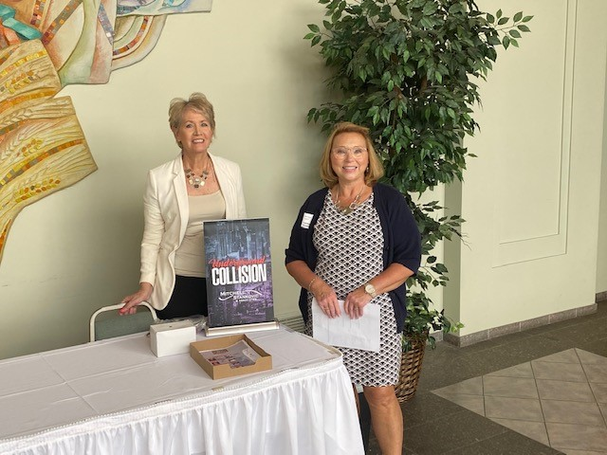The Underground is known for colliding with major industry events to create energy, build buzz and begin off-stage conversations. On Wednesday, August 18th, Michigan thought leaders brought in the Underground to collide with local credit unions. Fabulous opportunity to spotlight how the Underground is morphing to achieve unexpected collaboration. How about these tidbits? “R & D stands for rip-off and duplicate” at most credit unions. Open new branches in financial deserts for equitable access and lower cost, instead of those prime spots next to lookalike consumers. Or DEI initiatives can lead to racism toward employees, so be ready. Not your normal conference banter!

Hosted by Carma Peters, CEO of Michigan Legacy CU, the Underground had CEOs, execs and front line staff from across Michigan and even Ohio. “We love the Underground Collisions both in-person and virtual. You can have polite conversations in a professional atmosphere, but it doesn’t often lead to change, Carma shared. “That’s what excites me about the Underground, it’s a movement that will take credit unions and leaders places that makes a difference.”

Zach Christensen, director at Mitchell, Stankovic & Associates and host of the event shared, “Launching our first “local” Underground to uniquely focus on issues that matter to the credit union community in Michigan was great and it had universal appeal for those thinking differently.”

Eric Schornhorst, Strategic Advisor at CU Solutions Group, an Underground partner, moderated panels on Max Impact Branching, Innovation Tweaks and DEI Realities. The panelists who joined Carma:

* Scott McFarland, CEO at Honor CU
* Amanda Denney, Director of DEI at MSU FCU
* Esteban Camargo, Manager of Communications & Content Marketing at CU*Answers
* Liz Winninger, CEO at Xtend, Inc.
* Jennifer Martines, EVP at FreeStar Financial CU

Susan Mitchell, CEO of Mitchell, Stankovic & Associates and founder of the Underground kicked off the collision stating, “The Underground is about being authentic and sharing what we are thinking. Putting ideas into action because brainstorming without impact is a waste of time.” Thank you, Michigan! If you are interested in bringing the Underground to your local community reach out to Zach Christensen for more information.

# # #

*Located in Boulder City, Nevada,* [*Mitchell, Stankovic & Associates (MSA)*](http://mitchellstankovic.com/index.html) *mission is to stand up for issues that will make a difference to a diverse world of people, the bottom line for credit unions and change member lives globally. Clients glow when asked about MSA because they know what a partnership truly means – working together to achieve financial democracy. Led by CEO Susan Mitchell, MSA believes that credit unions have a social purpose, and its consulting services emphasize doing the right thing as good business, garnering sustainable growth and relevance within the market. From CEO Leadership Transitions to Strategic Planning to Modernizing Board Governance, MSA consulting practice has 25-year clients who have become champions to encourage new clients from all over the world. Serial entrepreneurs, MSA consultants have founded industry initiatives like the* [*Underground Movement*](http://mitchellstankovic.com/underground.html)*, Global Women’s Leadership Network, CU Pride, HRD Network and they volunteer on governing bodies of Worldwide Foundation and Credit Union DEI Collective.*