Underground Collision “TikTok” Thought Speakers Announced
Mitchell Stankovic Hosts Underground Collision in DC, February 27

Zooming into Washington DC for a real-life Underground Collision is an inspiring 30 second TikTok thought! Now envision the excitement of being in a socially responsible room with some of the brightest minds in the industry and you have a dream come true.

The Underground Collision on February 27th at the Top of the Hay-Adams Hotel (overlooking the White House) is the perfect setting to welcome people back and enjoy no slides, no coloring between the lines, no saying no. Instead, time to listen, speak your mind and say yes to action. There’s going to be some good, grassroots conversations and lots of “just between us” moments. Look who will be there:
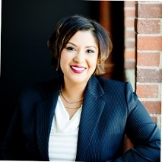
Shazia Manus, SVP of Experience Capabilities, CUNA Mutual, taking on the topic, I Can Do It. “While transformational change is far from an individual sport, it hinges on the renegade spirit. Leaders must commit to empowering themselves as independent thinkers and explorers before they can empower others as bold risk takers. If each of us, independently stands up one by one, and says I CAN DO It, collectively we will change the world,” stated Shazia. “Leading by example takes both self-actualized ambition and humility. It begins with modest introspection, migrates to influence and gains momentum through alliance.”
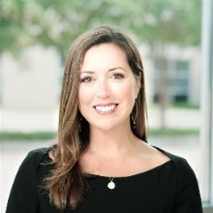
Samantha Paxson, Chief Experience Officer from CO-OP Financial Services will bring her innovative spirit and share why We Can Do It. “Opportunities abound for credit unions who put their members at the center. Innovation in the form of digital experiences to meet every day needs, built on the foundation of trust and collaboration of the industry is a great pathway to growth.”

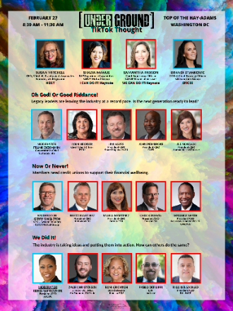
Time to capture the attention of a billion people a day, the TikTok way. “Short, concise, and real conversations are needed,” challenged Sue Mitchell, “Just like at the dinner table. Except we will respectfully arrive at key actions that can be taken.” At the Underground, the model for Collisions has been simple and consistent. Thought leaders stand up, make a point, get the audience engaged and drop (pass) the mic to invoke passion for getting stuff done:

Oh, God or Good Riddance – Leadership Transitions. Frank Diekmann, Chief Collaborator at CUToday will be the moderator of this critical issue and Jim Hayes, CEO of SECU; Lynn Heckler, CTO of PSCU; Jill Nowacki, CEO of Humanidei and John Pembroke, CEO of CUES will start us off.

Now or Never – Financial Wellbeing. Gerry Singleton, VP CU System Relations at CUNA Mutual will be the moderator of this critical issue and Brett Martinez, CEO of Redwood CU; Maria Martinez, CEO of Border FCU; Chuck Purvis, CEO of Coastal CU and Maurice Smith, CEO of Local Government FCU will challenge the industry to join them in the “good” fight!

We Did It – Ideas into Action. Renee Sattiewhite, President/CEO of the AACUC will be the moderator because she’s done it right and Roni Crichton, Board Director of Kinecta FCU, Pablo DeFilippi, EVP of Inclusiv, Rico Delgadilo, President/CEO of BALANCE and our very own, Zach Christensen, Director of MSA & Co-founder of CU Pride will tell it like it is.

Brandi Stankovic, CSO and COO of CU Solutions Advisory Group will be our host and provide the closing remarks on GSD. A new acronym for some and reality for others. You have to be there to experience the Underground TikTok Thought Collision! For our amazing virtual followers, you don’t have to get up early, we will be sending you a link to Underground TV following the live event!

To register for this event, click here!

# # #
Mitchell, Stankovic & Associates (MSA) mission is to stand up for issues that will make a difference to a diverse world of people, the bottom line for credit unions and change member lives globally. Clients glow when asked about MSA because they know what a partnership truly means – working together to reach beyond what is, to what can be. MSA believes that credit unions have a social purpose, and its advisory services emphasize doing the right thing as good business, garnering sustainable growth and relevance within the market. Serial entrepreneurs, MSA consultants have founded industry initiatives like the Underground Movement, Global Women’s Leadership Network, CU Pride, HRD Network and they volunteer on governing bodies of Worldwide Foundation and Credit Union DEI Collective.
CO-OP Financial Services is a payments and financial technology company whose mission is ensuring the success of the credit union movement. CO-OP payments solutions, engagement services and strategic counsel help credit unions optimize member experiences to consistently provide seamless, personalized multi-channel offerings, while delivering secure, sophisticated fraud mitigation service. For more information, visit www.coop.org.
CUNA Mutual Group Built on the principle of "people helping people," CUNA Mutual Group is a financially strong insurance, investment and financial services company that believes a brighter financial future should be accessible to everyone. Through our company culture, community engagement, and products and solutions, we are working to create a more equitable financial system that helps to improve the lives of those we serve and our society.

