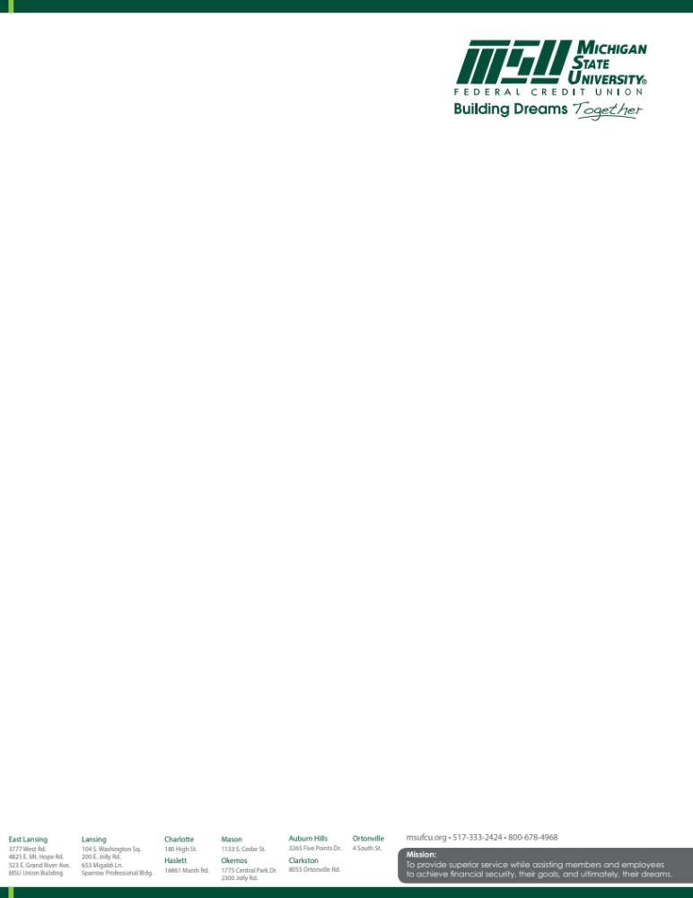

FOR IMMEDIATE RELEASE
February 16, 2021
Contact: Deidre Davis
Chief Marketing Officer
517-333-2424 ext. 7877
deidre.davis@msufcu.org

MSUFCU Hosts Annual Student Art Exhibit; WILX 10 Televises Announcement of Winners

EAST LANSING, Mich. — MSU Federal Credit Union (MSUFCU) is pleased to host the MSUFCU Student Art Exhibit at its Headquarters lobby now through February 24, 2021. This annual event allows area high school students to display their artwork for family, friends, and community members to view and enjoy.

This year, community members can review the exhibits and vote in person or online. During a special televised event on Sunday, March 14 at 10:30 a.m. on WILX 10 student winners will be announced in the following categories:
- People’s Choice - first, second, and third place
- Juried Winners
- Social media winner
- Honorable mention winners
“This exhibit allows families, fellow students, teachers, and the community to celebrate the accomplishments of area high school student artists. These students truly have amazing talents!” said Whitney Anderson-Harrell, MSUFCU Chief Community Development Officer. “It is a privilege to sponsor the MSUFCU Student Art Exhibit, and each year, we eagerly look forward to seeing the student exhibits. We enjoy sponsoring this event and displaying their wonderful artwork.”
To view the artwork and vote in person, visit MSUFCU Headquarters building at 3777 West Road, East Lansing between 9:00 a.m. to 5:00 p.m., Monday through Friday, and 9:00 a.m. to 3:00 p.m. on Saturday, or vote online by visiting msufcuart.com. And remember to tune into WILX 10 on Sunday, March 14 at 10:30 a.m. to learn which student artists are named winners.

Founded in 1937, MSUFCU has a national reputation for excellence and has received several top industry and workplace awards, including being named as a Top Workplace in the large employer category by the Detroit Free Press for eight consecutive years, a Top 100 Best Workplace for Women by Fortune for three consecutive years, and is in the top five Michigan credit unions by Forbes Best-in-State Credit Unions. MSUFCU was named a Best Workplace in Financial Services and Insurance by Fortune Magazine two consecutive years, and has been certified as a Great Place to Work® for seven consecutive years. MSUFCU has also been recognized by the Credit Union National Association, recently winning first place for the people-helping-people philosophy 2020 Louise Herring Award. MSUFCU is headquartered in East Lansing, MI, has 21 branches, more than 300,000 members, over $5.7 billion in assets, and nearly 900 employees. For more information, visit msufcu.org.

# # #

