**Affinity Plus Federal Credit Union**

175 West Lafayette Frontage Road

St. Paul, MN 55107

**For Immediate Release Contact:** Hillary Kline

Senior Public Relations Specialist

[hkline@affinityplus.org](mailto:hkline@affinityplus.org)

920-570-2761

**Affinity Plus CEO Dave Larson Makes List Of Top Minnesota Business Leaders**

*Larson recognized in Greenspring Media’s Minnesota 500*

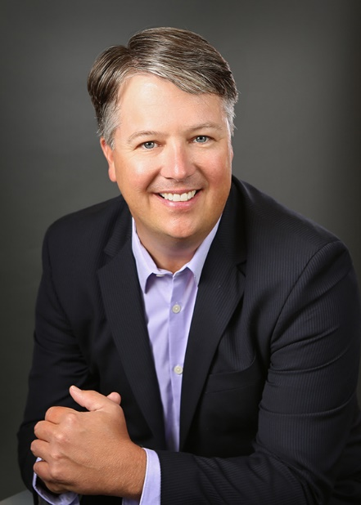**ST. PAUL, MINN. (January 10, 2022)** – Affinity Plus Federal Credit Union (Affinity Plus) is pleased to announce that President and CEO, Dave Larson, was recently listed in the 2020 Minnesota 500 ranking of, “The Most Powerful Business Leaders in Minnesota.”

The list, which is produced by Greenspring Media, celebrates the state’s leading business executives across an array of industries, from sports, to education, government to banking. Editors hand-selected this year’s top 500 Minnesota Executives.

“Dave continues to demonstrate his ability to inspire and motivate all employees to continuously deliver the highest quality service in the most difficult of times,” said Robyn Cousin, Board Vice Chair, Affinity Plus Federal Credit Union. “His understanding of servant leadership is reflected in the understanding and care he takes of employees and members. At a time of high stress and pandemic fatigue he has provided resources to employees and flexibility to members. I'm especially proud of how he seized the moment to continue our work to embed Diversity, Inclusion and Belonging into the culture of Affinity Plus. The sign of a great leader is using the challenges we face to foster our vision and goals."

Finalists for Minnesota 500 were selected following research and due diligence, considering criteria such as:

* The impact each executive has had/is having on their industry as a whole (both in current and prior roles);
* The success and impact the company itself has had/is having under his/her leadership;
* Special awards or accolades both in the executives’ professional and/or personal lives; and
* Participation in community/philanthropic endeavors, position on other boards, and the like.

Larson was also recently named Board Chair of Special Olympics Minnesota. In addition to the Minnesota 500, Affinity Plus has received a few other awards over the years. Forbes has ranked Affinity Plus as a Best-In-State Credit Union, a Star Tribune Top Workplaces survey also recognized Dave as the top leader among Minnesota’s large companies amongst the company as a whole being recognized as a Top Workplace.

To learn more about Affinity Plus, please visit [www.affinityplus.org](http://www.affinityplus.org).

*###*

**About Affinity Plus Federal Credit Union**

*Based in St. Paul, Minn., Affinity Plus Federal Credit Union is a not-for-profit, financial cooperative that puts people first above profits. Members of Affinity Plus receive maximum value through competitive rates, minimal fees, and unique, member-centric products and programs. Established in 1930, Affinity Plus has 28 branches located throughout Minnesota and is owned by more than 230,000 members. Affinity Plus has more than $3.5 billion in assets. Additional information is available at www.affinityplus.org or by calling (800) 322-7228.*