FOR IMMEDIATE RELEASE For more information, contact
Sharon Simpson, 240.620.4095
sgsimpsonconsulting@me.com

MyUSA Credit Union Supports Local Organizations through Casual for a Cause

January 25, 2022, Middletown, Ohio – MyUSA Credit Union will continue matching employee donations to its Casual for a Cause program throughout 2022. The program has resulted in over $30,700 in donations to date for local organizations, including Project READ, Shared Harvest Food Bank, Alzheimer’s Association Miami Valley Chapter, Credit Unions for Kids & Children’s Miracle Network – Dayton Children’s Foundation, and more.
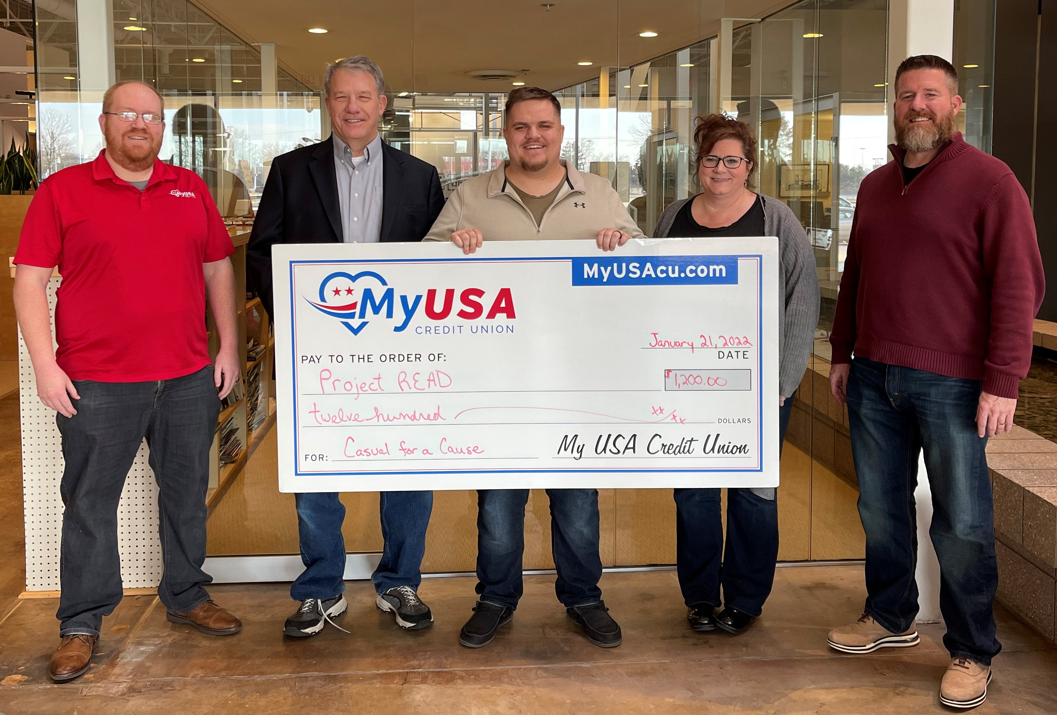
Pictured left to right: Kendrick Walker, Tom Farnbacher, Austin Burley, Margaret Hale, and Matt McFarland.
Each month MyUSA Credit Union employees select a cause to support with their casual dress donations. The Credit Union matches those donations to present a total gift of $1,200 to the charity of choice.
Employees have enthusiastically embraced our Casual for a Cause Program. The collaborative nature of the program allows our small organization to provide meaningful support to admirable causes that benefit the communities we serve.

About MyUSA Credit Union
MyUSA was formed with the successful partnership of MidUSA Credit Union, originally formed in 1934 by a group of Armco Steel workers who desired a better local alternative for their banking, and Heartland Federal Credit Union, originally the Dayton Telco Employees Federal Credit Union. From these humble beginnings on the shop floor and telco switching stations to a thriving $350 million credit union serving over 25,000 members, MyUSA has always held member trust and confidence close to heart. Focusing on leading the membership toward financial success and providing expanded service and support have been hallmarks of MyUSA’s proud combined 170-year history. Headquartered in Middletown, Ohio, MyUSA can be found online at www.MyUSAcu.com.
###

