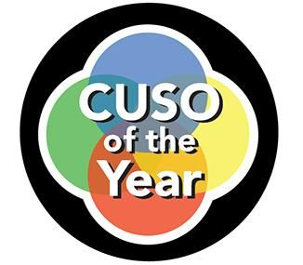
For Immediate Release
Contact: Shawna Luna
Email: Shawna@nacuso.org
Phone: 888-462-2870

Six CUSOs Receive Prestigious Awards Presented by NACUSO

Grand Rapids, MI (November 18, 2021) – NACUSO honored six CUSOs at the 2021 NACUSO Network Conference for driving value to the industry with innovative solutions crafted through collaboration. The NACUSO Network Conference took place November 8 through 11 at the Encore Las Vegas Resort, with the prestigious CUSO Awards presented the morning of Wednesday, November 10.

The CUSO Awards have evolved over the years as they date back to 1998 and 2021 is no different as NACUSO announced a brand new award to be presented: the CUSO of the Year Distinguished Service Award. This new award was specifically designed to recognize CUSOs who have been building among the industry for decades and inspiring others to do the same. The Distinguished Service Award was chosen from nominations received for 2021 CUSO of the Year which recognizes CUSOs that have served the industry for longer than five years. Additionally, up-and-coming CUSOs younger than five years old may be nominated for the New CUSO of the Year.

Evaluation of the sixteen total nominees was no easy feat as each shared inspirational stories that best demonstrate thought leadership, innovation in organization design, value created through collaboration, and a proven track record of positive results.

The awards committee conducted interviews with each nominee and ultimately the below six CUSOs were awarded for their cooperative efforts:

2021 CUSO of the Year Award Winner - LoanStar Technologies

2021 CUSO of the Year Honorable Mention - QCash Financial

2021 Distinguished Service Award Winner - United Solutions Company

2021 New CUSO of the Year Award Winner - Payac CLG

Last but not least, two 2021 New CUSO of the Year Honorable Mentions were awarded to Curql Collective, LLC and Nymbus CUSO.

Additional details on the CUSO Awards, photos, and event highlights can be found at nacuso.org and nacusonetwork.com with additional updates to follow.

About NACUSO
NACUSO (National Association of Credit Union Service Organizations) was formed in 1985 to help credit unions explore the use of CUSOs and the delivery of non-traditional products and services. Over the years, NACUSO’s focus has evolved to educating credit unions on the benefits of collaboration, helping credit unions find innovative collaborative partners & solutions, helping CUs form multi-owned CUSOs that help credit unions achieve economies of scale, risk reduction and obtain expertise, as well as being the collaboration focused regulatory & legislative advocate for CUSOs and their credit union owners.

###

