Contact: Chris Call, CEO
North Bay Credit Union
397 Aviation Way, Santa Rosa CA 95403
707-584-0384 • chris@NorthBayCU.com • NorthBayCU.com
September 10, 2021

Download high-resolution photo here.

Total pages: 2
North Bay Credit Union Named a
Best Credit Union to Work For
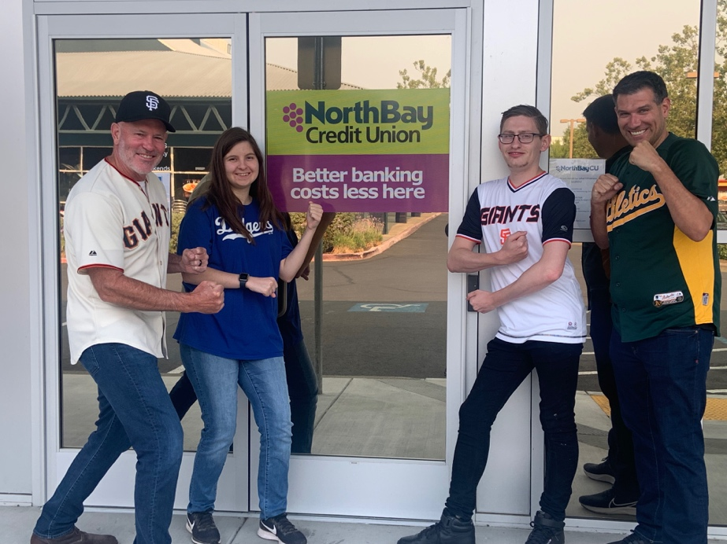
SANTA ROSA — North Bay Credit Union was ranked nationally as one of the “Best Credit Unions to Work For” by American Banker — and one of only three California credit unions selected.
According to North Bay CU CEO Chris Call, the credit union values each of its employees and works hard to give them the tools they need to succeed.
In addition to competitive salaries, the credit union provides a generous benefits package, including an incentive plan.
North Bay CU staff enjoying sports team spirit day.
Working during the pandemic has presented challenges for staff morale. The majority of staff have been given the opportunity to work remotely. Call notes that events like favorite sports team attire and ugly socks day are simple and fun diversions for staff working in the branches that members enjoy, too.
What sets North Bay CU apart, according to Lynnette Barlesi, Operations Manager, is that employees are empowered to make decisions and ensure members get the assistance they need. “One of our employees said recently that he enjoys coming to work here every day to see how he can say yes to members. This captures the spirit and speaks to the rewarding experience the staff has at North Bay CU.”
Call noted that staff diversity helps the credit union better serve everyone. “Nearly 75% of our staff is female, 33% are non-Anglo and a quarter are under age 30. And combined, our staff speaks a total of 13 languages. I think the unique and diverse perspectives of our team help us make more informed decisions.”
North Bay CU has $100 million in assets and offers a full range of loans, including mortgages, vehicle loans, home loans, agricultural loans and private student loans as well as free rewards checking. The credit union is federally insured by the NCUA and serves everyone who lives, works, or worships in Sonoma, Marin, Napa and Solano counties.
Learn more about North Bay CU at www.NorthBayCU.com.

###

