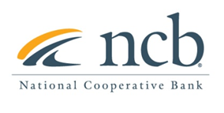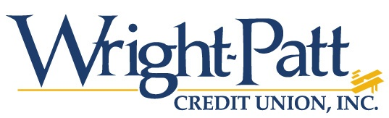

NEWS RELEASE
Contact:
Mary Alex Blanton – NCB (703) 302-8876
Tracy A. Szarzi-Fors-WPCU (937) 912-7114

National Cooperative Bank Partners with Wright-Patt Credit Union to Provide $16 Million to Five Rivers Health Centers New Facility
Arlington, VA (January 25, 2021) National Cooperative Bank (NCB) along with Wright-Patt Credit Union, (WPCU) recently closed a $16 million loan to support a $31.6 million New Markets Tax Credit (NMTC) financing package for the development of a 2 ½ story, 84,000 sq. ft. healthcare facility on four acres of land in Dayton, Ohio. The facility will replace five existing leased clinic spaces and will provide integrated and expanded services in one location. Five Rivers new facility will be known as the Edgemont Campus. NCB and WPCU will each provide a term in loan in the amount up to $8 million.
Five Rivers Health Centers is an independent 501(c)3 not-for-profit organization that provides comprehensive primary health care to individuals and families who are primarily residents of Dayton, Ohio. Five Rivers Health Centers currently serves more than 25,000 patients with more than 87,000 visits to community residents.
“NCB is proud to work with Wright-Patt Credit Union, in securing the financing necessary for Five Rivers to expand and provide critical health services to the residents of Dayton, OH”, stated Bob Montanari, Senior Vice President at National Cooperative Bank. “As a lender who specializes in the healthcare industry, we know the impact that affordable healthcare can bring to a community and look forward to the completion of the campus.”
“Wright-Patt Credit Union is excited to support the construction of this new community health resource”, stated Scott Everett, Vice President of Member Business Services/New Ventures. “Five Rivers is an exceptional resource for Greater Dayton and led by a fantastic leadership team. We look forward to future opportunities to partner with Five Rivers toward improving outcomes for those we both serve.”

About National Cooperative Bank:
National Cooperative Bank is dedicated to strengthening communities nationwide through the delivery of banking and financial services, complemented by a special focus on cooperative expansion and economic development. NCB provides financial products and services for the nation’s cooperatives, their members, and socially responsible organizations. Headquartered in Washington, DC, the Bank has offices in Alaska, New York, Ohio and Virginia. To learn more, visit www.ncb.coop, National Cooperative Bank on Facebook and Instagram, or on Twitter @natlcoopbank.

About Wright‐Patt Credit Union
Established in 1932, Wright‐Patt Credit Union is a member‐owned, not‐for‐profit financial cooperative proudly serving Central and Southwest Ohio with more than 421,000 members and over $6.2 billion in assets. As a cooperative, Wright‐Patt Credit Union joins members together, pooling financial resources to meet the needs of all. The pooled resources provide the capital to run a strong and efficient operation. Wright‐Patt Credit Union is headquartered in Beavercreek, Ohio, and has convenient Member Centers throughout Central and Southwest Ohio. Wright‐Patt Credit Union’s mission is to help people through life by allowing members to achieve a greater degree of economic independence. Visit Wright‐Patt Credit Union’s website at www.wpcu.coop for more information.

