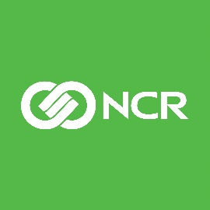 | NEWS RELEASE

NCR and Google Cloud Collaborate to Accelerate Digital Transformation in Banking

ATLANTA – April 27, 2021 – NCR Corporation (NYSE: NCR), a global enterprise technology provider for the financial industry, and Google Cloud today announced a global strategic partnership. Under the terms of the agreement, NCR will expand cloud availability of its Digital Banking software portfolio, including NCR Channel Services for retail banking as well as its card and payments processing platform NCR Authentic.

“This initiative expands the cloud deployment options for NCR’s customers, making it easier and faster for financial institutions to bring new digital banking services to market and accelerate digital transformations with confidence,” said Frank Hauck, President and General Manager of NCR Banking. “Financial institutions will benefit from NCR’s depth of banking industry experience along with the trusted, secure cloud platform provided by Google Cloud.”

NCR and Google Cloud will collaborate on product development and innovation to further enhance the suite of cloud-based solutions and analytics available to banking customers on Google Cloud. Google Cloud is a leading infrastructure, platform and industry solutions provider, helping businesses solve their most critical problems across 200 countries. With the ubiquitous Google Cloud, NCR’s customers will gain a leading solution for powerful computing, data storage and powerful analytics, and business insight.

“We’re partnering with NCR to help accelerate the digital transformation of financial services organizations,” said Derek White, vice president, Global Financial Services at Google Cloud. “Bringing NCR’s widely adopted digital banking software onto Google Cloud means financial institutions can leverage scalable, secure cloud infrastructure, with the flexibility to deploy new, cloud-native solutions across on-premises, hybrid cloud, and as-a-service models, enabling them to deliver exceptional customer experiences.”

About NCR Corporation
NCR Corporation (NYSE: NCR) is a leading software- and services-led enterprise provider in the financial, retail and hospitality industries. NCR is headquartered in Atlanta, Ga., with 36,000 employees globally. NCR is a trademark of NCR Corporation in the United States and other countries.

Web site: www.ncr.com
Twitter: @NCRCorporation
Facebook: www.facebook.com/ncrcorp
LinkedIn: www.linkedin.com/company/ncr-corporation
YouTube: www.youtube.com/user/ncrcorporation

Media Contact
Scott Sykes
(917) 232-6720
scott.sykes@ncr.com

