

**United Federal Credit Union – Press Release**

April 21, 2021

Contact: Diana Wake

Phone: (888) 982-1400 ext. 6891

Email: [dwake@unitedfcu.com](mailto:dwake@unitedfcu.com)

United Federal Credit Union, 150 Hilltop Road, St. Joseph, Michigan, 49085

**United Federal Credit Union Names Nick Iosue**

**Senior Commercial Loan Officer in Asheville, North Carolina**

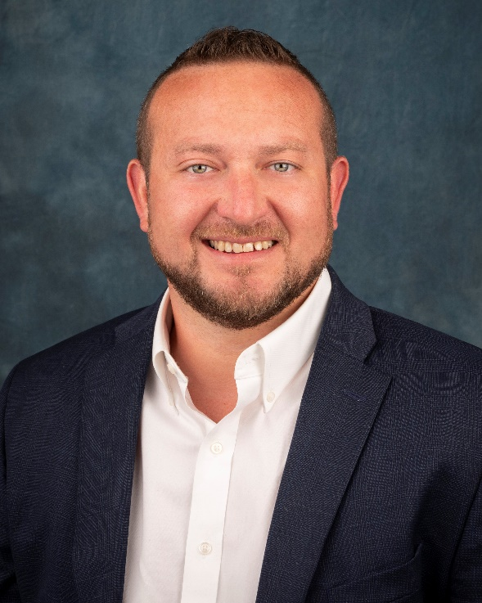

*Nick Iosue, Senior Commercial Loan Officer, Asheville*

**ASHEVILLE, N.C** – United Federal Credit Union (United) has appointed Nick Iosue to the position of Senior Commercial Loan Officer, serving the Asheville market.

As the Senior Commercial Loan Officer, Iosue will provide quality business lending expertise through financial counseling and product awareness to credit union Members regarding their business financing needs.

Iosue brings more than 12 years of financial industry experience to his new role. Prior to joining United, Iosue was the VP of Business Banking at First Citizen Bank in Hendersonville. He has a degree in accounting and corporate finance from Western Carolina University and is a graduate of the North Carolina School of Banking at UNC Chapel Hill.

Iosue lives in Western North Carolina with his wife and two daughters and is heavily involved in the community. He has served as a council member on the NC Young Bankers Association, Vice President of the Brevard Chamber of Commerce and Treasurer of Pisgah Forest Rotary.

**____________**

**About United**

United Federal Credit Union has served its Members since 1949 by helping them to build a sound financial future. United consists of more than 179,000 Member/owners worldwide and manages assets in excess of $3.3 billion. Its corporate offices and main branch are in St. Joseph, Mich., with additional branches in Arkansas, Indiana, Michigan, Nevada, North Carolina, and Ohio. Federally insured by NCUA. Equal opportunity lender. Equal housing lender. For more information visit [www.unitedfcu.com](http://www.unitedfcu.com)

# # #