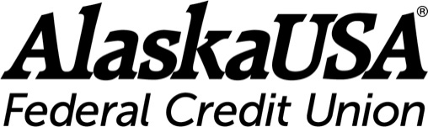

FOR IMMEDIATE RELEASE

August 5, 2021

Alaska USA Opens Member-Centric Designed Branch in North Pole, Alaska

Anchorage, Alaska – Come and take a look at the future of banking. Alaska USA Federal Credit opens its newest, fully redesigned, digitally focused branch located in North Pole, Alaska.

The new facility was the latest opening in a series of branches created in collaboration with a design company. The new space is an environment that completely reimagines what it means for members to engage with their credit union—and for the credit union to engage with members.

Branches continue to play a vital role in growing and supporting member relationships. “As part of our efforts to improve the member experience we are evaluating our branch presence and delivery service models in each of the communities we serve,” said Shannon Conley, Executive Director, Retail Financial Services. “Relocating the North Pole branch to the mall and updating its look will assist in our efforts to cast our branches as places where people can go to receive financial education, advice, and complete their transactions.”

Alaska USA is focused on providing exceptional member service; the new branch will serve members six days a week in an easily accessible location.

- North Pole Branch, 301 N. Santa Claus Lane, Suite 5 | Monday - Saturday 10 a.m. - 7 p.m.

“We are enhancing self-service options and showing members how to use the Alaska USA app, saving them time and allowing them a safe space to conduct their transactions,” said Conley.

More about Alaska USA
Alaska USA Federal Credit Union is a member-owned, not-for-profit financial cooperative with more than $10 billion in assets and more than 700,000 members worldwide. The credit union operates more than 90 branches and service facilities in Alaska, Arizona, California, and Washington State. Alaska USA offers a 24/7 Member Service Center and access to more than 55,000 surcharge-free ATMs worldwide, as well as online and mobile solutions.

Learn more at alaskausa.org.

###

Media Contact
Dan McCue
Senior Vice President, Corporate Relations
Alaska USA Federal Credit Union
907-786-2807
D.McCue@alaskausa.org

