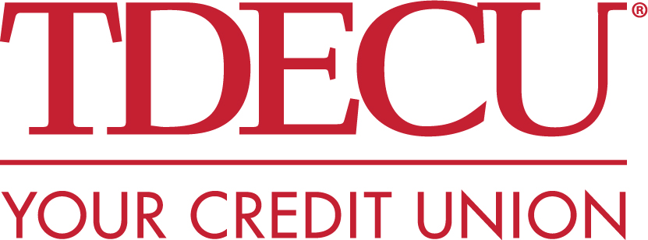
Media Contact:
Merideth Miller, M2 The Agency
281.882.3045
pr@m2theagency.com

FOR IMMEDIATE RELEASE: Executive Leadership Announcement from TDECU

(Lake Jackson, TX) — TDECU has announced a change in leadership with the resignation of President and CEO, Stephanie Sherrodd, effective April 30th. After almost 17 years with the credit union, including more than 8 years at the helm, Stephanie will be leaving TDECU to pursue outside opportunities. Under her leadership, TDECU experienced unprecedented growth, expanded products and services to a growing membership base, and became recognized as a best-in-class credit union across the industry.

“On behalf of the Board of Directors, our Leadership Team, and Employees, we are forever grateful for her leadership, her commitment to the credit union mission and our community - and we wish her all the best in her new pursuits,” said Board Chairman, Dick Smith.

"I feel fortunate to have served the TDECU Board of Directors, Employees, and Members these past years, and am proud of our team's unwavering commitment to our credit union mission, and our community,” states Sherrodd.
“I am grateful for the relationships, and the partnerships that have allowed our team to deliver on the growth and success of our credit union. Thank you to the community of Lake Jackson who have embraced my family – we look forward to our next chapter and the future."

Effective immediately, Isaac Johnson, TDECU’s SVP, Chief Administrative, Legal and Diversity Officer, will lead the organization forward as Interim CEO. In addition to a proven history of banking leadership at TDECU, USAA, and Wells Fargo, Isaac proudly serves our nation as Commanding General, 351st Civil Affair Command.

Smith commented, “We are confident Isaac is the right leader to ensure business continuity for our Members and Employees as we engage in a formal search for our next CEO. While change is never easy, we are excited to see what this new chapter holds for our credit union as we continue to provide the resources our Members need to improve their lives through growth, innovation and digital transformation.”

“I appreciate Steph’s leadership over the years, and thank the Board of Directors for entrusting me to take the reigns and lead our organization during this period of change,” states Johnson. “I am committed to supporting our Employees, Members and partners as we stay focused on delivering on our credit union mission and serving our communities.”

About TDECU
Founded in 1955, TDECU is a not-for-profit financial cooperative with more than 354,000 Members and over $4 billion in assets. TDECU currently has 35 Member Centers, and offers a complete selection of convenient, innovative, and competitive products and services, including a full suite of deposit products as well as mortgage, auto and personal loan products, online and mobile banking. TDECU also offers, through its subsidiaries, retirement planning and wealth management, personal and business insurance products. Members can also access a worldwide network of over 55,000 surcharge-free ATMs. For more information visit TDECU.org or call (800) 839-1154.

-###-

