FOR IMMEDIATE RELEASE
Kate Fruscione, Public Relations Strategist
(518) 458-2195 ext. 4394
kfruscione@capcomfcu.org
CAP COM MOURNS DEATH OF FORMER CEO PAULA STOPERA
ALBANY – July 7, 2021 – It is with great sadness and heavy hearts that we acknowledge the passing of CAP COM Federal Credit Union’s former President/CEO, Paula Stopera.

Paula joined the credit union in 1980 as a Membership Relationship Officer when CAP COM had just 9 employees. By 2004 she had ascended to the role of President/CEO. Serving for over 15 years in that role, Paula oversaw CAP COM’s record growth to 130,000 members, almost $1.8 billion in assets and over 360 employees. Paula was known throughout the Capital Region as a strong proponent of corporate giving and service, and she leaves a legacy of philanthropy both personal and professional. In 2003 Paula, along with Sharon Phillips, founded the CAP COM Cares Foundation which has donated approximately $5 million to local non-profits. She retired from CAP COM in 2019.

“Paula’s influence on CAP COM is beyond measure,” stated President and CEO, Chris McKenna. “As the architect of our philanthropic culture and a passionate advocate for our ‘every member, every time, every day’ philosophy, Paula shaped the direction of CAP COM forever. Her infectious personality, her steady hand and her huge heart will be missed by all of us.”

CAP COM Board Chair Pat Kelly noted, “Paula’s legacy of service and stewardship of our credit union over many years, stands tall amongst all of us. The CAP COM family of companies mourns the loss of an extraordinary woman, businesswoman, mother and grandmother.”

Paula’s influence in the Capital Region community went well beyond her role at CAP COM. Her positive impact lives on in the many charitable institutions she supported, the men and women she mentored, and her legacy of support for a growing and thriving Capital Region business community. Paula’s greatest passion was her family and the love for her children and grandchildren. She is survived by her daughter Amanda Goyer, son-in-law Chris Goyer, and beloved grandsons Roen and Noah. In her passing, Paula joins her beautiful son Alex Stopera.

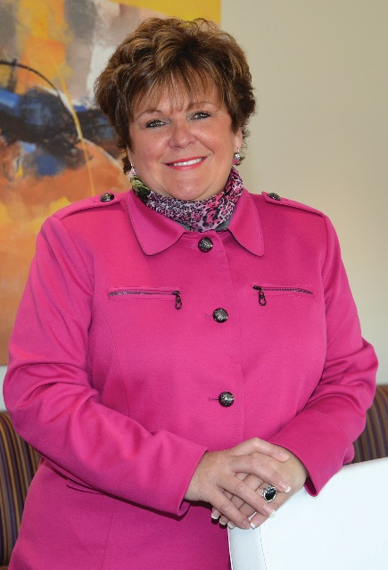

CAP COM Federal Credit Union is a member-owned financial institution based in the New York’s Capital Region with more than $2 billion in assets and 12 branch locations. The credit union is member-driven and focused on superior service, convenient products and competitive rates that help members save money and make life easier. CAP COM offers all the products and services you’d find at a typical financial institution. Visit www.capcomfcu.org to find out more. Federally insured by the National Credit Union Administration.
CAP COM Cares Foundation was established by CAP COM Federal Credit Union in 2003 to nurture the community by supporting health and wellness programs; financial literacy and education initiatives; and causes that assist underprivileged families. Since inception, the Foundation has donated over $4 million and over 35,000 volunteer hours to hundreds of organizations in the Capital Region. The CAP COM Cares Foundation is a 501(c)(3) charitable organization.

