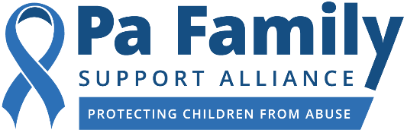


FOR IMMEDIATE RELEASE

Contacts:
Caitlin O’Connor, PFSA
412.719.5366
cailtlin@ceislermedia.com

David Misner, PSECU
717.777.2169
dmisner@psecu.com

Pennsylvania Family Support Alliance and Leading Sponsors to Recognize 2020 PA Blue Ribbon Champions for Safe Kids Recipients

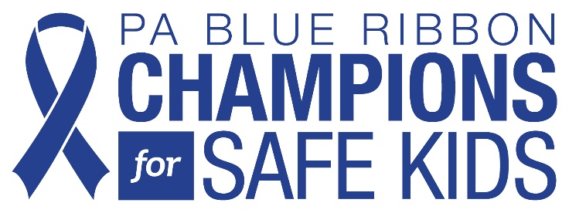
The PA Blue Ribbon Champions Awards honor professionals
and everyday heroes who #ProtectPAKids from neglect and abuse.

Harrisburg, PA (February 2, 2021) – Pennsylvania Family Support Alliance (PFSA), the state leader in child abuse prevention, and its leading sponsors, including Pennsylvania’s anytime, anywhere digital credit union, PSECU, will return to the annual tradition of honoring PA Blue Ribbon Champions for Safe Kids recipients this spring. The PA Blue Ribbon Champions for Safe Kids are individuals who volunteer or work with children and who have gone above and beyond the call of duty to #ProtectPAKids from neglect and abuse.

PFSA will honor these individuals throughout the month of April, nationally recognized as Child Abuse Prevention Month. Every week during April will be devoted to honoring one PA Blue Ribbon Champion. PFSA will debut a video detailing the recipient’s story and why the individual has advocated for children and made a difference in their lives. Blue Ribbon Champions have been chosen by a team of independent judges.

PFSA will host weekly virtual webinars featuring experts in the field of child welfare who will share best practices for supporting families and protecting our most vulnerable citizens. PFSA will also unveil an interactive map featuring county-specific child abuse data to demonstrate the statewide impact of child abuse and neglect. The weekly series will conclude with a moving tribute to the 51 children who lost their lives as a result of child abuse in 2019.

“Now more than ever, we need to work together as a community to ensure Pennsylvania’s children have the opportunity to grow up in a safe environment,” said Angela M. Liddle, President and CEO of the PA Family Support Alliance. “Our vision is to create a future that is free of abuse and neglect, and in order to make that vision a reality, everyone - organizations, companies, government agencies, and individuals – must step up. That’s why I’m so thankful for corporate sponsors, like PSECU, that take social responsibility seriously and value the health and safety of all children.”

According to the Pennsylvania Department of Human Services’ Annual Child Protective Services Report, 51 children in the Commonwealth died of child abuse in 2019. A total of 4,865 children were victims of abuse, including 93 children who suffered near-fatal injuries.

“With the PA Blue Ribbon Champions for Safe Kids Awards, we’re coming together as a Pennsylvania community to recognize and thank individuals who go above and beyond the call of duty to make sure our children are safe from harm while also raising awareness of this very serious issue,” said PSECU President and CEO George Rudolph. “As a credit union, PSECU follows the ‘people helping people’ philosophy. Our support of Pennsylvania Family Support Alliance and these recipients is a demonstration of that commitment; on behalf of our more than 475,000 members across the state and beyond, we’re excited to be involved in this very important program.”

Raising awareness about the signs of child abuse and neglect are more important than ever right now. With the nation in the midst of a public health crisis due to the COVID-19 pandemic, many children are socially isolated and not in school. This means that there are fewer mandated reporters, like teachers, daycare workers, and school bus drivers, interacting with and seeing children on a daily basis. With schools implementing hybrid learning models to protect children and teachers from the coronavirus and parents struggling to properly supervise their children, many families are unclear how to navigate the current reality our society is experiencing. Because this is an unprecedented time, PFSA created a comprehensive list of COVID-19-related resources for parents, families, and other caregivers. These resources include information on how to cope with stress, parenting during the pandemic, and how to talk to your children about the coronavirus.

About Pennsylvania Family Support Alliance
Pennsylvania Family Support Alliance prevents child abuse and protects children from harm by helping parents learn positive parenting techniques, educating professionals and volunteers who work with children to recognize and report child abuse, and helping community members learn how they can play a positive role in keeping children safe. To learn more about our programs, schedule a training, or donate, please visit pafsa.org, or call 800.448.4906.

About PSECU
Opened in 1934, PSECU was founded by 22 ordinary people who pooled $90 and made an extraordinary commitment to each other: To create a financial institution where collective resources benefit all members. Today, PSECU continues that legacy as Pennsylvania’s largest credit union, managing $7.5 billion in assets and offering its more than 475,000 members convenient anytime, anywhere digital banking options. PSECU was named a 2020 Best-In-State Credit Union by Forbes Magazine. For more information about PSECU, visit psecu.com. View its Year In Review to learn how PSECU contributes to the greater good.

# # #

