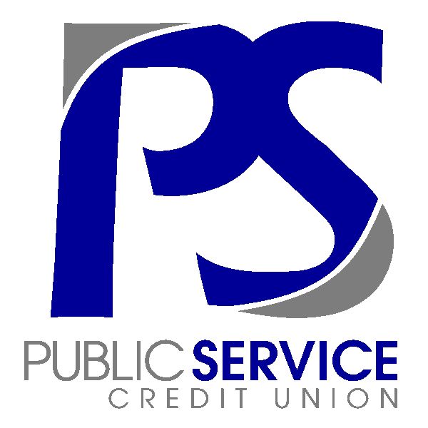

CONTACT INFORMATION:
Public Service Credit Union
Lindsay Gallmeyer
260-432-3433 ex1105
lgallmeyer@mypscu.com

FOR IMMEDIATE RELEASE

Public Service Credit Union Continues Tradition of Giving Back to Members & the Fort Wayne Community

Fort Wayne, IN – In 2020, the staff at Public Service Credit Union was determined to find a way to invigorate the spirit of giving back into a bleak year. Instead of letting 2020 stop them, they let it inspire them! Project Giveback was created, and a new tradition began.
For Project Giveback 2021, PSCU surveyed members and identified local charities and people in need. Knowing the power and joy of giving back, PSCU employees started shopping to find the perfect gifts to fulfill hundreds of holiday wishes for its members, staff, and the Fort Wayne community.

An event was held on Saturday, December 11th at PSCU’s West Jefferson Boulevard location. Members were invited to get their gifts, a holiday photo, cupcake and hot cocoa. Santa was there to pass out gifts and remind us that we have so much to be thankful for. “I get to do all the shopping for the members” said employee Amanda Grimwood. “My favorite part is reading the surveys and finding the perfect gift, and then getting to watch them open it. When you find the perfect gift, and you got it just right, seeing their reaction is the best!”
After the event, even more gifts were sent out, charitable donations were made, and care packages were delivered to local police, firemen, nurses, and postal workers. “It felt awesome to give back to the community” said Branch Manager, Ashley Zehr. “Just to see the smiles on the members faces made it all worth it.”

A video was created to capture the excitement of the day: https://www.mypscu.com/project-giveback-2021/

Public Service Credit Union is Fort Wayne’s oldest credit union. Founded in 1932 the full-service financial institution serves over 4,500 members through two branch locations and a full suite of electronic tools.
###

