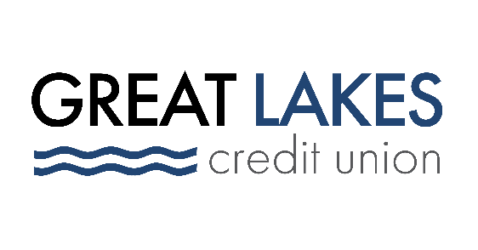

The New Year Offers New Hope for Paying Down Personal Debt

As consumers bid goodbye to 2021, the new year also presents the perfect opportunity to begin paying off accumulated personal debt.

But simply resolving on January 1 to pay off debt in the new year is not enough to make a financial impact. Instead, consumers can focus on establishing new behaviors to help them manage their money differently.

“Saying you want to pay off debt can be a great goal, but it’s important to create more tangible, manageable objectives that feel attainable,” said Michael Hersh, Chief Administrative Officer, who oversees lending and housing/financial counseling at Northern-Illinois based Great Lakes Credit Union (GLCU).

Taking Action to Manage--and Pay Down--Consumer Debt

Here are some more action-oriented resolutions to consider:

- Resolve to pay more than the minimum amount due on your biggest debts. You can pay off debt faster, and save on interest payments, by paying more than just the minimum.
- Resolve to consult a pro. There are many certified financial counselors that can help you with your money questions, and tailor solutions specifically to fit your circumstances. “GLCU offers to its members and even non-members in our communities access to independent, HUD-certified housing and financial counselors,” said Hersh. “They can help folks gain control of debt and prepare for responsible homeownership, and better understand what financial tools make sense for them.” To find a HUD-approved housing counseling agency near you, check out the U.S. Department of Housing and Urban Development’s website at hud.gov.
- Resolve to consolidate debts. Debt consolidation can be a good way to gain better control of your finances. Options include things like personal loans or home equity loans, but perhaps the best-known option is taking advantage of reasonable balance transfer offers for credit cards. Not sure what your best option is? Talk to a certified financial counselor to get their perspective.
- Resolve to track your spending and payments. Consider apps like Debt Payoff Planner, Qoins, Digit and Mint. Or, look at what your financial institution offers. Many banks and credit unions offer aggregators or budgeting tools to help you track your saving and spending.
- Resolve to spend intentionally. Consider deleting credit card information from online stores or websites. “You’ll have to really think about a purchase before just clicking ‘buy,’” said Hersh, “and even that little bit of friction can be enough to make change your mind or consider whether this is the right purchase at the right time.” Plus, you’ll be reducing the risk that your credit card information is stolen should the third-party website be breached by hackers. You can also consider storing your card on your favorite mobile wallet – payment will be easy, but you’ll still need to think about it before making the transaction.

Not all debt is bad, and in fact some can be helpful – think mortgages and auto loans, which help you finance things you need. But if you’re a consumer who wants to fully pay off your debt, your most important resolution should be resolving to have patience. As with any worthwhile goal, the road to debt freedom will take some time and effort, but it can be an attainable goal.

About Great Lakes Credit Union
Founded in 1938 and headquartered in Northern Illinois, GLCU is committed to financial empowerment for you. As a not-for-profit financial cooperative with over $1 billion in assets, GLCU is proud to serve more than 80,000 members in the Chicagoland and surrounding areas. Learn more about GLCU’s accounts, educational initiatives and community development programs at glcu.org.

