FOR IMMEDIATE RELEASE

Contact:

Carla Bagley March 15, 2021
7901 Sandy Spring Road
Laurel, MD 20707
Phone: 800-787-8328, ext. 7144

Email: carla.bagley@towerfcu.org

Tower Federal Credit Union’s VP of Information Security & ISO Joins Panel of Aronson P2B, a Shark Tank-style Tech Event

Phil Mellinger will serve as a panelist at Aronson LLC’s upcoming Aronson P2B, an innovative virtual tech event similar to ABC’s popular reality show, Shark Tank.
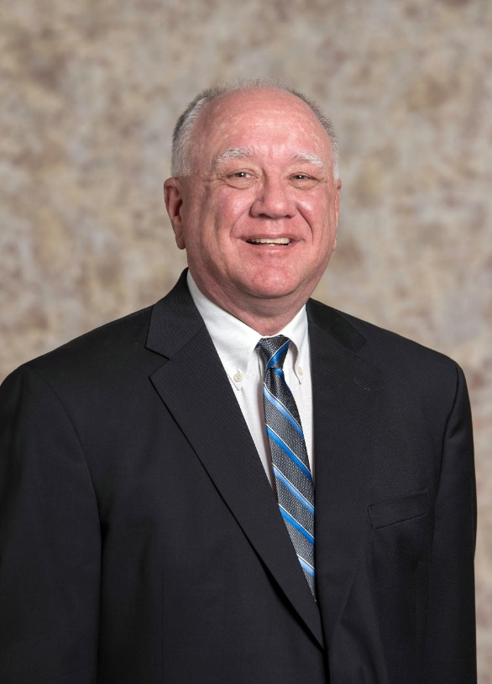
Phil Mellinger, Vice President of Information Security & Information Security Officer for Tower Federal Credit Union, will be a panelist at Aronson LLC’s innovative upcoming tech event, Aronson P2B. The private, virtual event takes place March 25, 2021.

Similar in format to ABC’s entrepreneurial-themed reality show Shark Tank, Aronson P2B provides an opportunity for emerging tech companies to present their company and products to local corporate executives, cybersecurity professionals and cyber/IT buyers.
Phil Mellinger, Tower Federal Credit Union

Companies that submitted applications prior to the February deadline and were selected by the event nomination committee will be given five minutes to virtually “pitch” to the panelists. Once the pitch is over, the panelists will provide feedback and offer insights on the company/product.

Mellinger brings to the event panel over 40 years of information technology and cybersecurity experience. Before joining Tower in 2017, he worked for Trusted Knight Corp., where he led development of technologies to combat malware in the financial industry. Prior to that, Mellinger spent 12 years at credit card payment processor First Data, where he was Chief Information Security Officer and led investigations into technologically-sophisticated attacks against the card payment industry.

Mellinger has also served as Chief Engineer at the General Services Administration, where he directed the design of the Federal Public Key cryptography program. He has a Master’s degree in Computer Science from Johns Hopkins University and an Applied Scientist degree in Computer Science from George Washington University. Mellinger holds four patents, including a method for testing the security of Internet merchants, and another for detecting advanced fraud techniques. He has another 13 patents pending.

According to Aronson, while no company will be named “winner” of the event, the goal of Aronson P2B is for each startup to expand its network, and for its founders to receive valuable feedback from industry experts, which they can then leverage to achieve success, whether through growth, R&D or acquisition.
#

About Tower Federal Credit Union
Tower Federal Credit Union is a member-owned, non-profit financial institution with headquarters in Laurel, Maryland. Established in 1953, Tower is the largest federal credit union in Maryland with over $3.3 billion in assets. We provide a full array of financial products and services and serve over 195,000 members worldwide. Tower serves its local-area members with 12 branches in Anne Arundel, Baltimore, Howard, and Prince George’s counties and four branches at Fort Meade, as well as online services and mobile banking at towerfcu.org.

