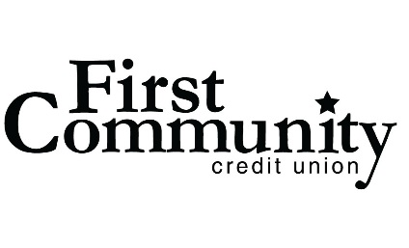
Contact: Laura Alfeldt, Marketing
T: 636-537-4462
lalfeldt@firstcommunity.com

FOR IMMEDIATE RELEASE
First Community Donates $8,000 to Local Charities
Chesterfield, MO (March 16, 2021) – During the last two weeks of December, First Community employees made monetary donations to Friends of Kids with Cancer and Nurses for Newborns. For a minimum of $10 each week they could wear jeans during either or both of those weeks. The credit union also made a corporate match to those donations. After the two weeks were over, the credit union was able to present each charity with $4,000 donations.
With these uncertain times during a pandemic, now more than ever donating and giving back to the community is needed. These donations were one of many that First Community has had the honor of being a part of throughout the tough year.
About Friends of Kids with Cancer:
Friends of Kids with Cancer is devoted to enriching the daily lives of children undergoing treatment for, and survivors of, cancer and blood-related diseases. Their mission is to be an advocate for these special kids providing them and their families with the educational, emotional, and recreational support needed as a result of the long hours of chemotherapy, illness and isolation. Friends of Kids with Cancer was founded in 1992.
About Nurses for Newborns:
Nurses for Newborn's mission is to provide a safety net for families most at risk; to help prevent infant mortality, child abuse and neglect through home based programs that provide education, healthcare and positive parenting skills. Nurses for Newborns was founded in 1991. It became a 501(c)3 organization in 1992. It is a nurse home visiting agency.

About First Community:
First Community Credit Union has been operating for over 85 years and serves over 350,000 members. First Community is in the top 100 credit unions in the nation and was recently named the top credit union in Missouri by Forbes. Its mission is to provide quality products and affordable financial services. It serves all persons living and working in the communities of St. Louis County, St. Louis City, Franklin County, Jefferson County, St. Charles County, Warren County, and the Illinois counties of Madison, Monroe and St. Clair.





