Contact: Nicci Yount, Marketing
T: 636-537-4420
nyount@firstcommunity.com

FOR IMMEDIATE RELEASE
First Community celebrates the opening of the newest branch.
Kirkwood, MO (February 17, 2022) – First Community opened the doors to their newest location in Kirkwood bringing the total number of branches to 42. Historic Kirkwood, with its beautiful homes and quaint business district, has long been on the list of places First Community wanted to be. This newly constructed branch is conveniently located right on Manchester just east of Lindbergh.
The festivities started off with a ribbon-cutting held on the first day the branch was open on January 19th, 2022. The Kirkwood Chamber of Commerce joined the staff at the new branch, along with some of the senior leadership team of First Community.
The branch then held its Grand Opening the week of January 31-February 5th. Throughout the week there were offers of incentives for youth accounts, free appraisals on refinances or purchases, and a special rate on a 48 month CD. The event portion of the grand opening consisted of Fredbird from the St. Louis Cardinals, Tony Patrico and Scott from the #1-morning show in St. Louis, The Rizzuto Show, and a balloon artist. The Saturday festivities were the St. Louis Blues Mascot, Louie, Chris Kerber (the Voice of the St. Louis Blues), a donut bar, and a balloon artist.
“Kirkwood, Missouri has always been such a desired space for First Community to move into, so we are extremely excited to finally open the doors on our newest branch. The community is so tight-knit, so we look forward to becoming part of their everyday banking needs,” explained Glenn Barks, President, and CEO.
During the festivities, First Community chose to support one of the local and highly regarded schools in the area, Carmelite Child Development Center. They were presented with a $500 check for their organization.
The manager of the branch, Kelly Warwick has 5 years of experience in management at First Community (16 years total at First Community), and she is thrilled to lead this branch to success with assistant manager, Nick Correnti, and Branch Supervisor Katherine Cramer.
About First Community:
First Community Credit Union has been operating since 1934 and serves over 360,000 members. First Community is in the top 100 credit unions in the nation and was recently named one of the top credit unions in Missouri by Forbes. Its mission is to provide quality products and affordable financial services. It serves all persons living and working in the communities of St. Louis County, St. Louis City, Franklin County, Jefferson County, St. Charles County, Warren County, and the Illinois counties of Madison, Monroe and St. Clair.

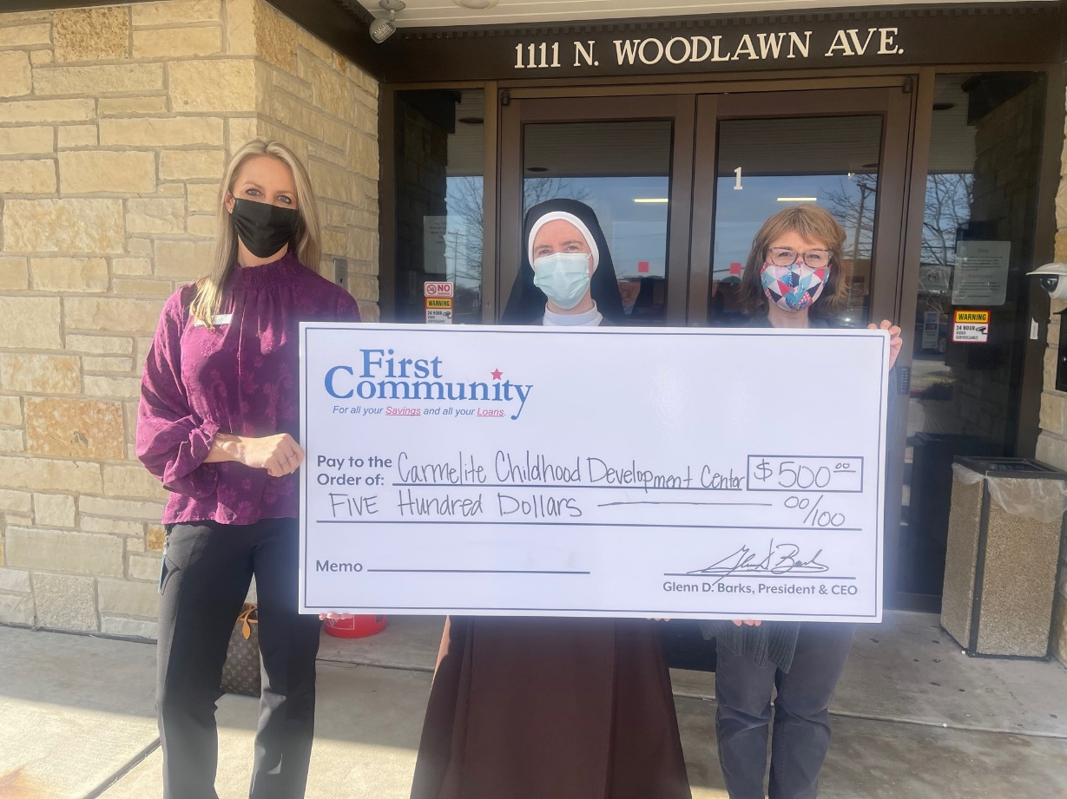

Pictured: Kelly Warwick (First Community), Sr. M. Immaculata and Kristen Wollaeger (Director of Carmelite Daycare)

