FOR IMMEDIATE RELEASE  February 11, 2022  CONTACT:  Glen Stacey  518-730-9044  glen.stacey@sunmark.org | 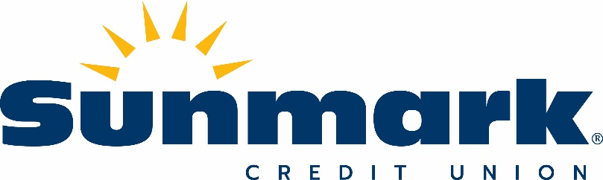

Sunmark Credit Union Announces commitment of $85,000 to Community projects in 2022

(Latham, NY) – Sunmark Credit Union announced during the recent Super Bowl 56 broadcast that the credit union is celebrating 85 years of building brighter financial futures by committing $85,000 to community projects throughout 2022 as part of its “Make Your Mark” giving program.
Sunmark has created a dedicated website at www.Sunmark85.com to track giving progress and share stories of the local organizations that have received funds as part of this commitment. Individuals and organizations are encouraged to visit www.Sunmark85.com to nominate community organizations that would benefit from receiving a share of the funds, or to make a donation to the Sunmark Charitable Community Foundation, which will disburse the funds throughout the year.
“Since 2015, the Sunmark Charitable Community Foundation has been providing financial contributions, in-kind services, and volunteer support to non-profit organizations in our communities. 2022 is a very special year for Sunmark, and we wanted to do even more to illustrate our commitment to the credit union mission of ‘people helping people,’” said Amber Cooleen, chief marketing officer for Sunmark Credit Union and president of the Sunmark Charitable Community Foundation.
“At Sunmark Credit Union we are committed to being a trusted financial partner that is small enough to know our members, but big enough to serve all of their financial needs with technology and personal service. By contributing an additional $85,000 to community projects, we can build something so much bigger than just a credit union,” said Sunmark Credit Union President and CEO Frank DeGraw.
In addition to committing $85,000 to support local organizations throughout Sunmark Credit Union’s 14-county charter area, Sunmark employees are also dedicating a combined 850 hours of volunteer time in support of community causes. To learn more, visit www.Sunmark85.com.

###

About Sunmark Credit Union: Since 1937, Sunmark Credit Union (nearly $1 billion in assets; 83,000+ members) has been helping members improve their financial position. Sunmark is committed to the financial health and well-being of each member by offering tools that educate and inform and products and services that make it easier to reach financial goals. For more information, call 518-382-0605 or visit www.sunmark.org.
About The Sunmark Charitable Community Foundation: Founded in 2015 the Sunmark Charitable Community Foundation has been supporting local, nonprofit organizations by providing financial contributions, in-kind services, and volunteer support. There are zero administrative costs: 100% of every donation goes directly to helping those who need it. For more information visit the foundation web page at https://www.sunmark.org/foundation.

