United Federal Credit Union – Press Release
April 28, 2021

Contact: Matt Orlando
Phone: (888) 982-1400 ext. 1473
Email: morlando@unitedfcu.com
United Federal Credit Union, 150 Hilltop Road, St. Joseph, Michigan, 49085

United Federal Credit Union Names Two New
Branch Managers at Marion, Ohio Locations

MARION, Ohio – United Federal Credit Union (United) has named two new branch managers to lead its Marion, Ohio locations. Joe Goney and Amy Marshall have been appointed to the position at the Marion East and Marion West branches respectively.

As Branch Manager, Goney and Marshall will be responsible for maintaining the performance of their branches, and providing leadership and supervision to staff.

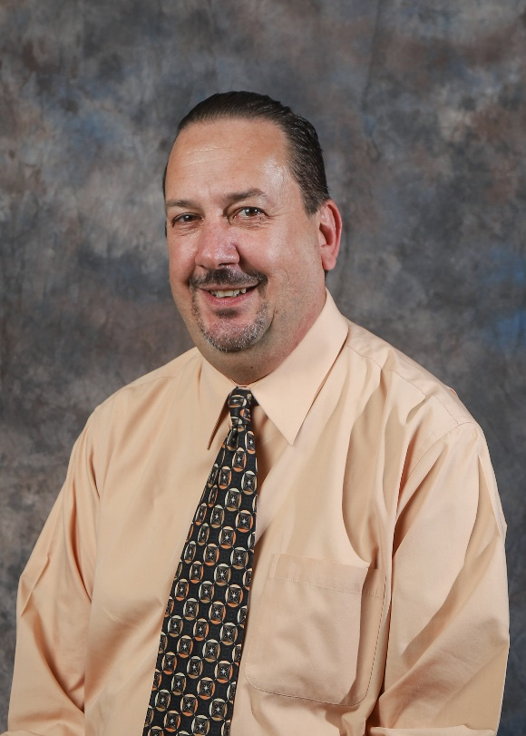
Joe Goney, Branch Manager, Marion East Branch

Goney brings three years of financial service experience to his role at United. Most recently, he served as Financial Solutions Center Manager for First Commonwealth Bank where he managed bank sales and developed relationships with area businesses.

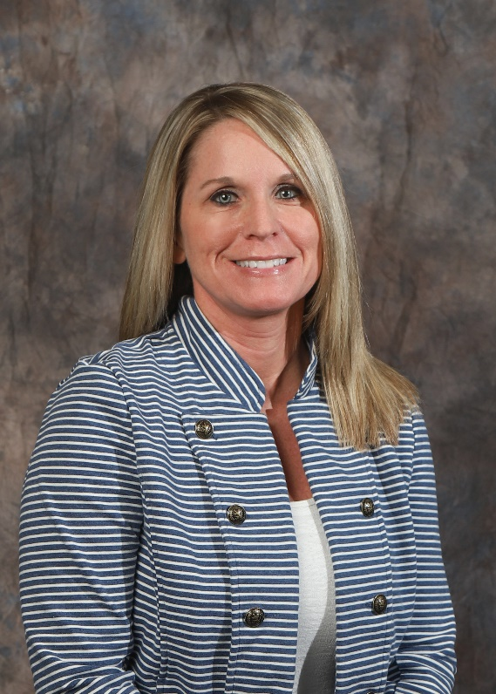
Amy Marshall, Branch Manager, Marion West Branch

Marshall has been with United for nearly seven years and has more than 20 years of financial service experience. In her most recent role with United, Marshall served as Member Service Advisor where she built relationships with Members and prospective Members.

Both Goney and Marshall are passionate about living the credit union philosophy of ‘people helping people’. In the community, they will be an advocate for United’s community impact efforts supporting organizations such as the Boys & Girls Club, the United Way, and other local non-profit groups.

____________
About United
United Federal Credit Union has served its Members since 1949 by helping them to build a sound financial future. United consists of more than 179,000 Member/owners worldwide and manages assets in excess of $3.3 billion. Its corporate offices and main branch are in St. Joseph, Mich., with additional branches in Arkansas, Indiana, Michigan, Nevada, North Carolina, and Ohio. Federally insured by NCUA. Equal opportunity lender. Equal housing lender. For more information visit www.unitedfcu.com

# # #

