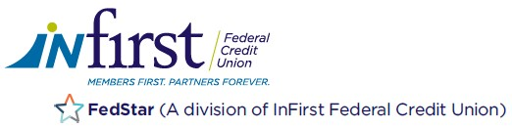

Contact: Christine Sparks
Marketing Manager
703.914.8700, ext. 1216
csparks@infirstfcu.org

FOR IMMEDIATE RELEASE
June 4, 2021

INFIRST FEDERAL CREDIT UNION AND FEDSTAR FEDERAL CREDIT UNION JOINTLY ANNOUNCE THEIR MERGER

Roanoke, VA – InFirst Federal Credit Union and FedStar Federal Credit Union are excited to announce that the two credit unions merged on June 1, 2021. The organization will operate under the InFirst Federal Credit Union name with combined assets of approximately $224 million, 8 branches, and serving nearly 14,000 members nationwide.

“We are excited to have the FedStar members and staff join the InFirst family. The two credit unions complement each other and share the same passion for member service,” said Martha Wye, President and CEO of InFirst Federal Credit Union. “This merger provides many benefits to our combined membership.” The credit union is scheduled to reopen the Melrose Branch located in Roanoke, VA by November.

InFirst Federal Credit Union is a member-owned cooperative, providing financial solutions to many active and all retired federal employees, associations, and businesses, members of the InFirst Responders Foundation, Inc., along with anyone who lives, works, worships or attends school in most of Salem, Roanoke, Botetourt, Vinton, and King George, VA, and their immediate family members. Originally chartered in 1935, the credit union remains financially strong with the same core values, products, services, and member focus. Visit infirstfcu.org to learn more about the credit union.

