

**Press Release  
For Immediate Release**Media Contact: Erin Forrester

412-719-0215  
                  Clearview Federal Credit Union

Lisa Florian

412-507-5147

Clearview Federal Credit Union

[press@clearviewfcu.org](mailto:press@clearviewfcu.org)

Clearview names Robin Redfern 2021 Joseph C. Cirelli Award Winner

14th annual award will benefit Bags & Blessings in Beaver County

***Pittsburgh, PA, June 24, 2021…****(*[*clearviewfcu.org*](https://linkprotect.cudasvc.com/url?a=http%3a%2f%2fclearviewfcu.org&c=E,1,emVL3UMKC1-dHRKWBTUaFBDb0Xb8X540ZTDZ-JUDp2HtOg-WkXaqgYDmUR40aTOr-n6LMU-22Sfaz64M_8fz6ThqHl2N4cc477bbbxS9I-15svDTnw,,&typo=1)) Clearview Federal Credit Union has announced Robin Redfern as the 14th Annual Joseph C. Cirelli Community Service Award recipient.

Ms. Redfern is not only a deputy sheriff and a dedicated volunteer - she founded Bags & Blessings. The vision for her organization started when she was dealing with her own cancer diagnosis. Robin received a gift bag in a moment when she felt like giving up and giving in. After going into remission in 2010, Robin started Bags & Blessings in her kitchen. The goal of Bags & Blessings is to help people who are going through treatment for cancer by providing wellness and self-care items to help heal their bodies and their spirits. Going beyond giving these bags, the organization also helps with support groups, including one for children and teens who have lost a parent or close family member from cancer or have one currently in treatment. The charity has also partnered with local organizations to create a memorial garden at Brady's Run Park in Beaver Falls.

President and CEO of Clearview, Ron Celaschi, states, "Clearview is proud to honor Robin for her accomplishments and recognizes all that the nominated individuals and organizations do to better the lives of those within our communities. This award bears the name of a long-time Clearview employee and former CEO, Joseph C. Cirelli, who recently passed away. He volunteered much of his time for charities and causes that fostered the spirit of Clearview's vision - Helping People to Enjoy a Better Life. We are honored to recognize Robin, who epitomizes Mr. Cirelli's legacy of service."

Bags & Blessings will receive a $5,000 donation in recognition of Robin's dedication.

View the award presentation [here](https://www.youtube.com/watch?v=JvHqqlr-C5E&t=192s).

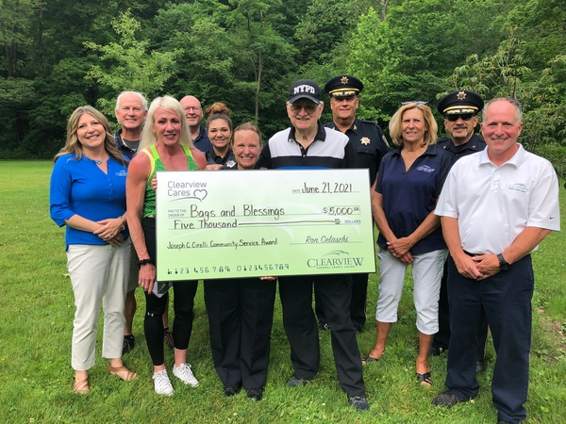

Pictured (l-r) – Lisa Florian - Clearview SVP Digital Strategy & Marketing, Brian B. Notman, Jr.- Treasurer - Clearview Board of Directors, Rachel Marchionda – Bags & Blessings, Jack Manning - Beaver County Commissioner, Kylee Cipolla – Deputy Beaver County Sherriff’s Department, Robin Redfern, award recipient, Brian O’Connor – father of Robin, Paul Radatovich - Deputy Chief Beaver County Sherriff’s Department, Cindy McConnell - Clearview Board of Directors, Tony Guy – Beaver County Sherriff, Ron Celaschi – Clearview President and CEO.

###

About Clearview Federal Credit Union  
  
Clearview Federal Credit Union has been in operation since 1953 and serves over 109,000 members with reported assets valued over $1.6 billion as of May 2021. Membership in Clearview is open to individuals who live, work, worship, volunteer or attend school in the Southwestern Pennsylvania community, which includes Allegheny, Armstrong, Beaver, Butler, Fayette, Greene, Indiana, Lawrence, Washington and Westmoreland counties. Membership is also open to immediate family members of current Clearview members. Visit clearviewfcu.org for more information. Clearview Federal Credit Union is federally insured by the National Credit Union Administration and is an Equal Housing Lender.