

**Press Release  
For Immediate Release**

Media Contact: Erin Forrester

412-719-0215  
                  Clearview Federal Credit Union

Lisa Florian

1-800-926-0003 ext. 21100

Clearview Federal Credit Union

[press@clearviewfcu.org](mailto:press@clearviewfcu.org)

Clearview provides increased community support during a year of uncertainty

Clearview Cares contributed over $150,000 in community efforts, 6,000 volunteer hours, and more.

***Pittsburgh, PA, January 20, 2022…****(*[*clearviewfcu.org*](https://linkprotect.cudasvc.com/url?a=http%3a%2f%2fclearviewfcu.org&c=E,1,emVL3UMKC1-dHRKWBTUaFBDb0Xb8X540ZTDZ-JUDp2HtOg-WkXaqgYDmUR40aTOr-n6LMU-22Sfaz64M_8fz6ThqHl2N4cc477bbbxS9I-15svDTnw,,&typo=1)) The year 2021 started as a year of uncertainty and presented a continued need in the community due to the COVID-19 pandemic. Clearview Federal Credit Union continued and increased its community support through the Clearview Cares initiative. In 2021, Clearview Cares benefited thousands of people throughout Southwestern Pennsylvania, including:

* More than $150,000 donated to support local community efforts.
* With food insecurity rising, an ongoing partnership with Greater Pittsburgh Community Food Bank delivered 33,000+ meals during Hunger Action Month.
* A Thanksgiving turkey distribution provided a holiday meal for over 200 families.
* Scholarships totaling $15,000 to high school seniors for secondary education.
* A financial literacy program benefitting over 5,000+ students.
* Donations of $20,000 to 4 local community organizations to spread the holiday spirit during a difficult holiday season.
* Clearview staff volunteered more than 5,700 hours in the community.

“Here at Clearview, we stand behind our vision of “Helping People to Enjoy a Better Life.” In doing so, we are proud that we continued to support our members, communities, and employees in the most uncertain of times. We are grateful for our membership, who are at the core of all that we do, our devoted staff and their continued selflessness during the ongoing pandemic, and to all the organizations making a difference in Southwestern Pennsylvania,” said President and CEO Ron Celaschi.

View Clearview’s Community Impact video [here](https://www.clearviewfcu.org/Community/Clearview-Cares?utm_medium=press-release&utm_source=clearview-cares&utm_campaign=impact-report#impact).

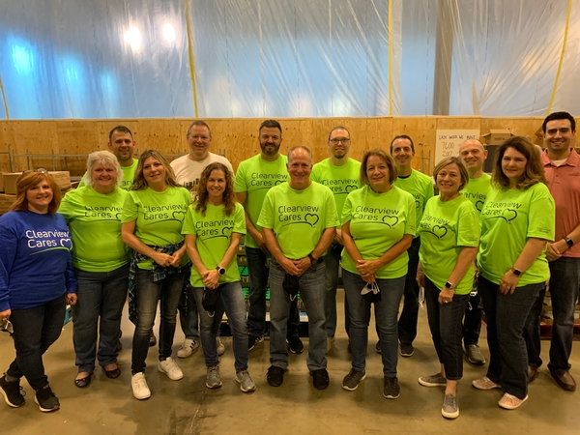

Clearview’s senior leadership volunteering at Greater Pittsburgh Community Food Bank in support of 2021 Hunger Action Month.

*Center - President and CEO Ron Celaschi*.

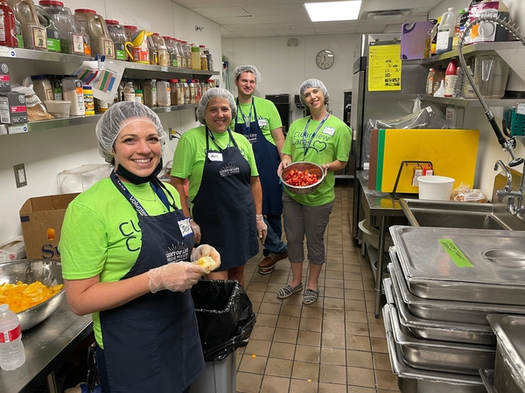

Clearview staff volunteering in support of Clearview Cares.

###

**About Clearview Federal Credit Union**

Clearview Federal Credit Union has been in operation since 1953 and serves over 110,000 members with reported assets valued over $1.6 billion as of December 2021. Membership in Clearview is open to individuals who live, work, worship, volunteer or attend school in the Southwestern Pennsylvania community, which includes Allegheny, Armstrong, Beaver, Butler, Fayette, Greene, Indiana, Lawrence, Washington and Westmoreland counties. Membership is also open to immediate family members of current Clearview members. Visit clearviewfcu.org for more information. Clearview Federal Credit Union is federally insured by the National Credit Union Administration and is an Equal Housing Lender.