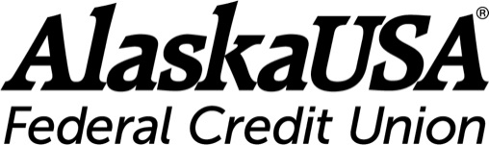**FOR IMMEDIATE RELEASE**

**Feb. 19, 2021**

Media Contact

Dan McCue

Senior Vice President, Corporate Relations

Alaska USA Federal Credit Union

907-786-2807

D.McCue@alaskausa.org

**Alaska USA Honors Alaska’s Military with Annual Appreciation Event**

26th Annual Military Appreciation Breakfast Curbside Pickup Style

**Anchorage, Alaska** – Alaska USA honored members of Alaska’s armed forces, including 12 recipients of the Service Person of the Year award and the Military Spouse of the Year, at Alaska USA’s 26th Annual Military Appreciation Breakfast in Anchorage.

Due to COVID-19, this year’s event was held outside the Historic Anchorage Hotel in a curbside pickup style. Honorees received an appreciation basket filled with breakfast goods and appreciation videos.

Though the breakfast was held in a different setting it didn’t hinder Alaska USA from reflecting on its military roots and celebrating 26 years of partnership.

“This is an event that Alaska USA looks forward to every year, so we were glad that we were still able to recognize the award winners in a COVID-19 friendly manner,” said Geoff Lundfelt, President and CEO, Alaska USA. “It’s truly an honor to be able to give back in some small way to those who have sacrificed so much for our country.”

The Service Person of the Year honorees were nominated by their supervisors and underwent a panel interview. These exceptional enlisted service members, representing each of the active duty branches of the Guard and Reserve, were recognized and awarded for their outstanding achievements.

The military breakfast takes place in conjunction with the Armed Services YMCA Alaska (ASYMCA) annual Salute to the Military event.

**More About Alaska USA**

Alaska USA Federal Credit Union is a member-owned, not-for-profit financial cooperative with $9.8 billion in assets and more than 675,000 members worldwide. The credit union operates more than 90 branches and service facilities in Alaska, Arizona, California, and Washington State. Alaska USA offers a 24/7 Member Service Center and access to more than 55,000 surcharge-free ATMs worldwide, as well as online and mobile solutions.

Learn more at [**alaskausa.org**](http://www.alaskausa.org).

-more-

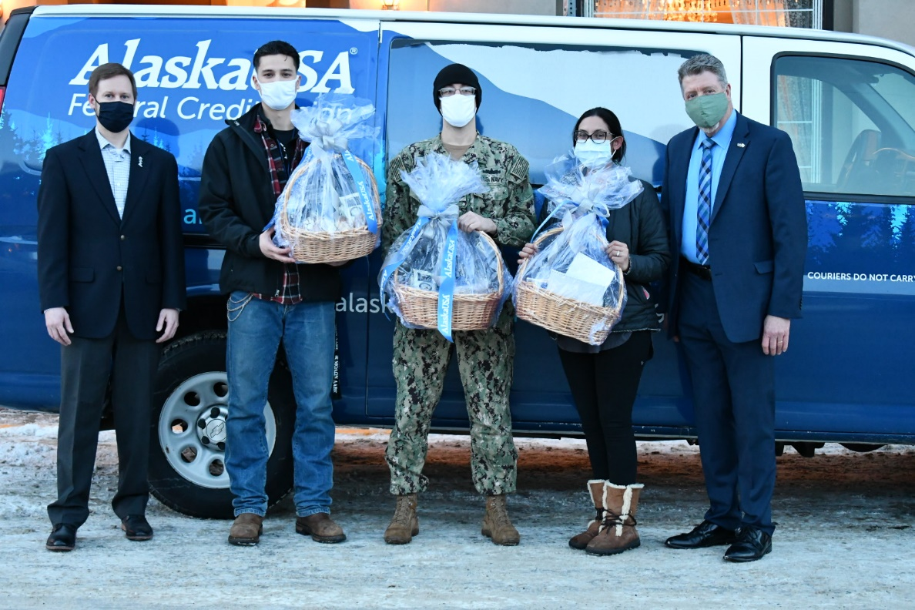

**Photo:** Recipients of the Service Person of the Year award receive an appreciation basket from Manager, Military Branch Operations Erik Lind and Senior Vice President, Corporate Relations Dan McCue.

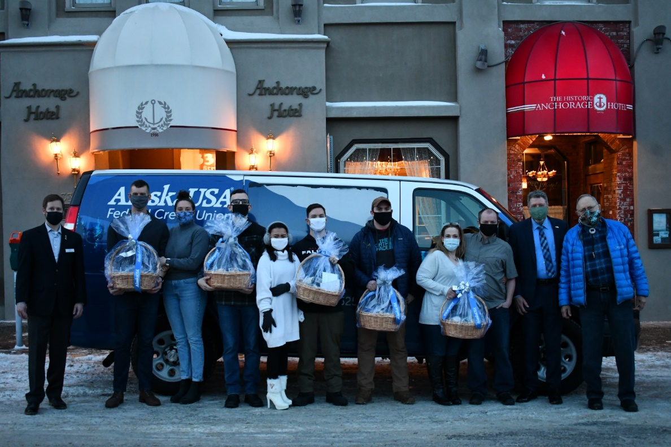

**Photo:** Recipients of the Service Person of the Year award receive an appreciation basket from Manager, Military Branch Operations Erik Lind; Senior Vice President, Corporate Relations Dan McCue and Congressman Don Young.

###