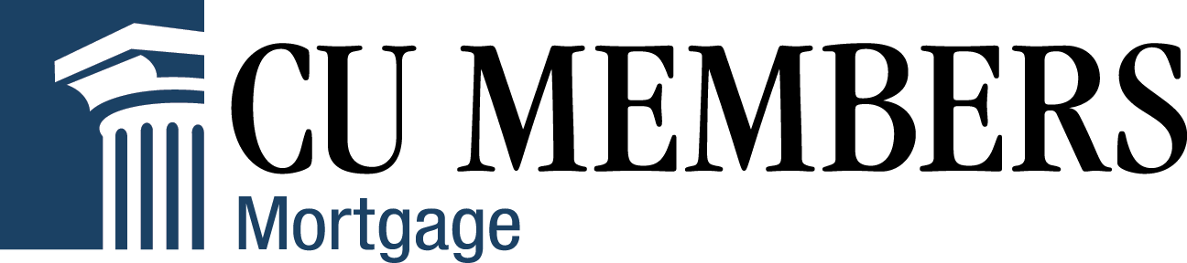
FOR IMMEDIATE RELEASE

CONTACT:

Alison Barksdale, Marketing Director
972-778-0661 x 3290
alisonb@homeloancu.com
www.cumembers.com

CU Members Mortgage Kicks Off 2021 Educational Series with Webinar Highlighting Changes to Uniform Residential Loan Application

DALLAS, TX –January 19, 2021 – CU Members Mortgage, a division of Colonial Savings, F.A., is kicking off their 2021 Educational Series with a webinar highlighting the changes to the Uniform Residential Loan Application (URLA). The webinar, The New URLA, will feature guest speaker MaryKay Scully, Genworth’s Director of Customer Education and will be held on Thursday, February 4 from 1 – 2 p.m. CST.

In this course, MaryKay will take a comprehensive look at the upcoming changes to the URLA and will discuss best practices for reviewing what is needed for a complete URLA, understanding why each piece of data is important, expediting the overall loan process to ensure smooth transfer from processing to underwriting and more. The new URLA will go into effect March 1, 2021 and has everyone in lending eager to understand how to maneuver around these changes.

“CU Members Mortgage is excited to kick-off our 2021 Educational Series covering the upcoming changes to the URLA,” said Steve Hewins, Senior Vice President of CU Members Mortgage. “CU Members Mortgage has a long-standing history with providing impactful and meaningful educational resources to credit unions and their members. We understand the importance our company plays in being a leader in the credit union services industry and look forward to continuing to provide education to credit union mortgage professionals across the country.”
About MaryKay Sculluy
As Genworth’s Director of Customer Education, MaryKay Scully leads the development of customer education curriculum. With 28 years of experience at GE/Genworth, she has also served as an E-Business Development Manager, Director of Customer Education and Organizational Effectiveness and a Service Center Manager. Prior to Genworth, she held Loan Officer positions at various mortgage companies in the Mid-Atlantic states. MaryKay’s extensive and varied experience make her a nationally sought-after instructor and round table participant for topics as far reaching as Purchase Transaction Best Practices to HMDA.
MaryKay is a graduate of the National School of Banking and received an MBA from Fairfield University. She has held Series 7 and Series 63 (Uniform Securities Agent License). She has been a function Black Belt in Six Sigma Quality and is a Certified Trainer in DiSC Behavioral Profiling
Chairman of the Mortgage Bankers Association of New Jersey Women's Committee (2019). Mortgage Professional America Elite Women Award in 2017 and 2018.

About CU Members Mortgage
Established in 1982 as a division of Colonial Savings, a federally chartered thrift, Dallas-based CU Members Mortgage provides comprehensive mortgage services to credit unions and CUSOs. CU Members Mortgage originates FHA, VA, Investment Property, Manufactured Homes and conventional loans nationwide. With a portfolio of $24 billion, Colonial is one of the largest servicers of mortgage loans in the United States. The company is privately held and has offices located nationwide. For more information, visit www.cumembers.com.

###

