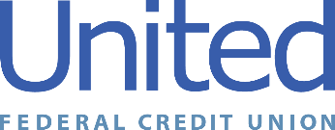

United Federal Credit Union – Press Release
November 8, 2021

Contact: Diana Wake
Phone: (888) 982-1400 ext. 6891
Email: dwake@unitedfcu.com
United Federal Credit Union, 150 Hilltop Road, St. Joseph, Michigan, 49085

United Federal Credit Union and American Red Cross
Partner for Blood Drive in Southwest Michigan

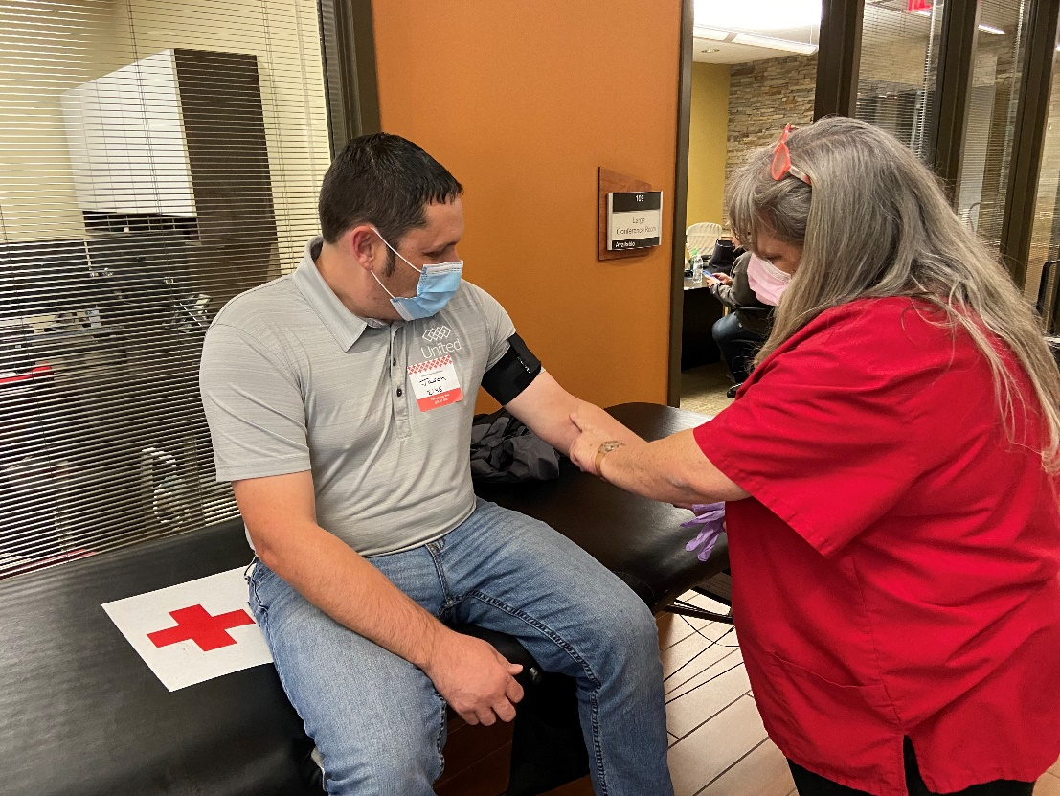
A United Federal Credit Union employee donates blood

ST. JOSEPH, Mich. – With an ongoing critical need for blood donations, United Federal Credit Union partnered with the American Red Cross to host a blood drive on November 5, 2021 at its former headquarters at 2807 S. State Street in St. Joseph, Michigan. Through the generosity of employees and individuals from the community, 23 pints of blood were donated.
“We are very thankful for the support of Team United, our Members, and the community with our recent blood drive. Once again, they saw a need in their community and stepped up to donate blood,” said Terry O’Rourke, United CEO and President. “Our partnership with the American Red Cross is extremely important. This event shows the positive impact that can be made in our communities by living the credit union philosophy of people helping people.”

The American Red Cross said the need for blood is constant and one donation can potentially save up to three lives. It provides about 40% of our nation’s blood and blood components, all from generous volunteer donors.

“The partnership between the American Red Cross and companies such as United Federal Credit Union are essential in helping to bring the community together to help the American Red Cross fulfill our mission to supply lifesaving blood products,” said Andrew Blake, Donor Recruitment/Account Representative for the American Red Cross.

Every two seconds someone in the United States needs blood, according to the American Red Cross. Donations from blood drives help patients of all ages: accident and burn victims, heart surgery and organ transplant patients, and those battling cancer.
____________
About United
United Federal Credit Union has served its Members since 1949 by helping them to build a sound financial future. United consists of more than 178,000 Member/owners worldwide and manages assets in excess of $3.7 billion. Its corporate offices and main branch are in St. Joseph, Mich., with additional branches in Arkansas, Indiana, Michigan, Nevada, North Carolina, and Ohio. Federally insured by NCUA. Equal opportunity lender. Equal housing lender. For more information visit www.unitedfcu.com

# # #

