

**United Federal Credit Union – Press Release**

January 31, 2022

Contact: Matt Orlando

Phone: (888) 982-1400 ext. 1473

Email: [morlando@unitedfcu.com](mailto:morlando@unitedfcu.com)

United Federal Credit Union, 150 Hilltop Road, St. Joseph, MI 49085

**Andrew Clarkson Named Vice President of National   
Mortgage Production at United Federal Credit Union**

**ST. JOSEPH, Mich. –** United Federal Credit Union (United) in St. Joseph, Michigan has announced the hiring of Andrew Clarkson to fill its newly created position Vice President of National Mortgage Production.

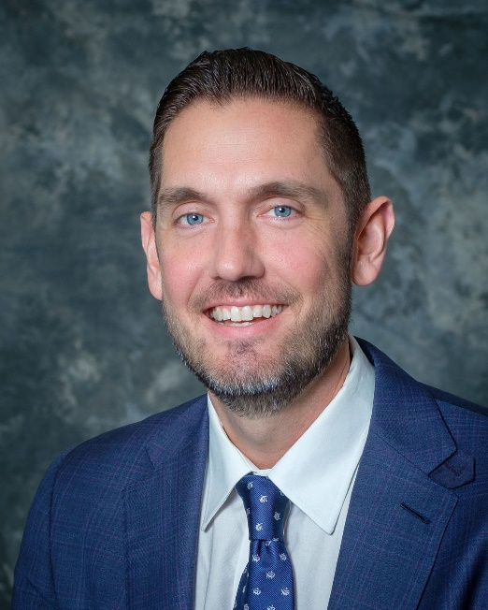

*Andrew Clarkson, Vice President of National Mortgage Production*

In his new role, Clarkson will be responsible for managing mortgage lending through collaboration with both internal and external partners to establish a market-led, comprehensive multi-year strategy for United. He will work alongside executive leadership to determine direction and target markets for mortgage

lending and make recommendations for lending policies to support that direction. In addition to strategic and portfolio growth initiatives, Clarkson will also be responsible for continued innovation of the mortgage lending line of business as well as the development and success of the directors of mortgage sales and inside mortgage advisors.

“I’m extremely happy to be working with a talented group of credit union mortgage professionals at United,” said Clarkson. “We have an incredible opportunity to grow and serve our regions the right way, by supporting members with new products and services, while also removing barricades for our mortgage advisors so that we can keep our mortgage radius expanding from where we are today. I am committed to achieving smart growth by creating efficiencies while promoting United’s dynamic culture for our employees and members alike.”

Clarkson brings more than 15 years’ experience in mortgage lending and production to the position. Prior to joining United, Clarkson held mortgage production positions at Quicken Loans, JPMorgan Chase, and BBVA. Most recently, he spent the past seven years as Vice President, Regional Mortgage Production at Lake Michigan Credit Union in Grand Rapids, Michigan.

“We are excited to welcome Andrew to lead our mortgage production team,” said James Knight, United’s Chief Sales and Service Officer. “His expertise, positive attitude, and drive to create a positive member experience make him a perfect fit at United. We have a lot of great ideas and big plans for our mortgage production in the future, and Andrew will guide us to success.”

Clarkson is a graduate of Michigan State University, and is an Accredited Mortgage Professional (AMP) and Certified Residential Mortgage Banker (CMB) from the Mortgage Bankers Association.

**____________**

**About United**

United Federal Credit Union has served its Members since 1949 by helping them to build a sound financial future. United consists of more than 191,000 Member/owners worldwide and manages assets in excess of $3.8 billion. Its corporate office and main branch are in St. Joseph, Mich., with additional branches in Arkansas, Indiana, Michigan, Nevada, North Carolina, and Ohio. Federally insured by NCUA. Equal opportunity lender. Equal housing lender. For more information visit [www.unitedfcu.com](http://www.unitedfcu.com)

# # #