United Federal Credit Union – Press Release
March 24, 2021

Contact: Matt Orlando
Phone: (888) 982-1400 ext. 1473
Email: morlando@unitedfcu.com
United Federal Credit Union, 150 Hilltop Road, St. Joseph, MI 49085

United Federal Credit Union Names Carrie Taylor
Mortgage Advisor at Edison Lakes Branch

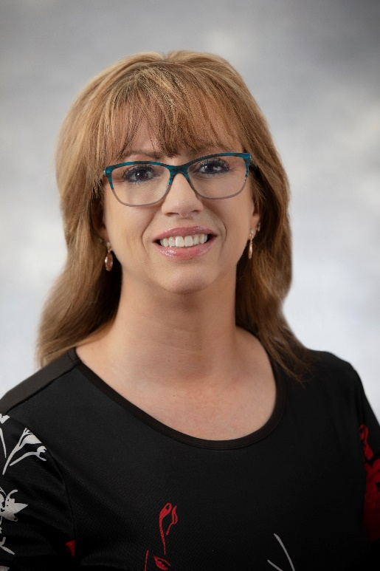
Carrie Taylor, Mortgage Advisor in Mishawaka, Indiana.

MISHAWAKA, IN – United Federal Credit Union (United) has appointed Carrie Taylor to the position of Mortgage Advisor at its Edison Lakes branch in Mishawaka, Indiana.

Taylor will use her expertise to provide quality real estate lending expertise through financial counseling and product awareness to credit union members regarding their real estate financing needs and generate investment quality mortgage loans.

Taylor brings more than 22 years of financial services and global procurement experience to her new role—including more than ten years in real estate. She pairs her industry knowledge with a passion to help people find the right mortgage option for their new home.

Most recently, Taylor served as a Title Processor and Escrow Officer at Meridian Title Corporation in Mishawaka, and spent eight years as a Real Estate Broker/Realtor for Cressy & Everett in South Bend.

In the community, Taylor has served as President, Treasurer, and Program Director for the Women’s Council of Realtors—South Bend Network as well as the Secretary for Indiana State Women’s Council of Realtors Network. She has also volunteered with Memorial Children’s Hospital, acting a s the Trivia Night Fundraiser Organizer for six years.

____________

About United
United Federal Credit Union has served its Members since 1949 by helping them to build a sound financial future. United consists of more than 179,000 Member/owners worldwide and manages assets in excess of $3.3 billion. Its corporate offices and main branch are in St. Joseph, Mich., with additional branches in Arkansas, Indiana, Michigan, Nevada, North Carolina, and Ohio. Federally insured by NCUA. Equal opportunity lender. Equal housing lender. For more information visit www.unitedfcu.com

# # #

