** FOR IMMEDIATE RELEASE**

**Del Norte Credit Union Celebrates Groundbreaking of Second Branch in Española, New Mexico**

April 7, 2021

Contact: Diego Muñoz | [dmunoz@dncu.org](mailto:dmunoz@dncu.org) | 505-455-5117

**Española, New Mexico, April 7, 2021** – Del Norte Credit Union, northern New Mexico’s hometown financial cooperative announced the official start of construction at the site of their second location in Rio Arriba county with a groundbreaking ceremony on Wednesday, April 7, 2021. With COVID precautions and social distancing guidelines in place, the groundbreaking celebration was held with a very limited number of guests.

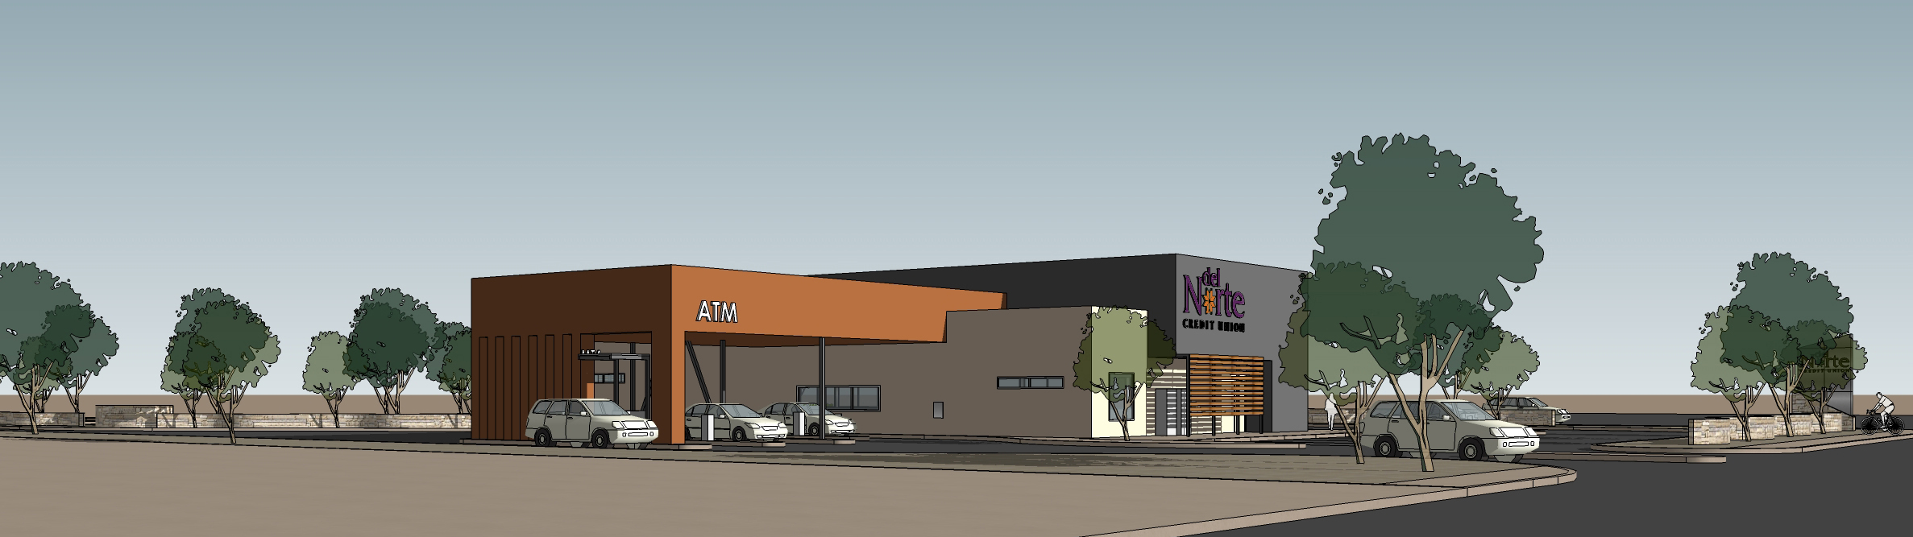

“Today is the beginning of an exciting journey as we build a new home to welcome our members to and we are keeping our fingers-crossed that we can see each other very soon,” said Deb Salazar, Chief Experience Officer at Del Norte Credit Union. “It’s been so hard for a lot us for so long, that this feels so right to be celebrating today—we get to look forward to our future together while serving our people, *nuestra gente*.”

DNCU is building their second full-service branch in Española at 1720 N. Riverside Drive. Located on the northeast side of Española, the brick-and-mortar location will help the credit union better serve members in outlying rural communities.

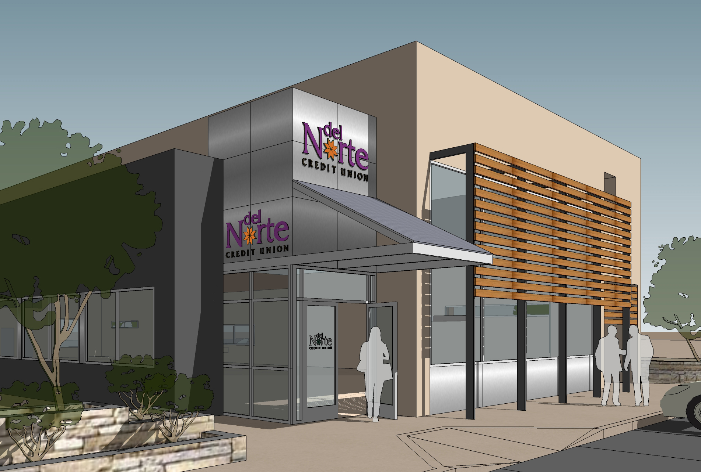

Construction of the one-story, 5,100 square foot branch is scheduled to be completed this fall. Once opened, the branch will be the eighth brick-and-mortar DNCU location in New Mexico and the third in Rio Arriba County.

“We are excited to begin construction on this location because we know the great impact it will have for so many members that travel long distances to complete their banking and finances with us,” explained Chuck Valenti, Del Norte Credit Union President & CEO. “Our goal is to make it as convenient as possible for our members and communities to access banking options that are looking out for their best interest—and that’s the cooperative difference.”

**About Del Norte Credit Union**

Chartered in 1954, Del Norte Credit Union is a not-for-profit credit union based in New Mexico with a mission of Improving Lives. DNCU offers a wide variety of products and services designed to make members achieve financial success. Today DNCU serves more than 57,000 members throughout New Mexico and the United States. Del Norte Credit Union is an equal opportunity employer and is federally insured by NCUA. NMLS# 500583

**###**