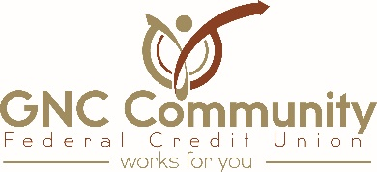

News Release
May 24, 2021

GNC Community Federal Credit Union Joins cuBIZloan.com

New Castle, PA and Princeton, NJ – cuBIZloan.com is excited to welcome GNC Community Federal Credit Union to cuBIZloan’s member business and commercial loan referral program.
cuBIZloan.com is a commercial and business lending service for businesses, investors, and not-for-profits. The referral program connects borrowers to a trusted lending partner, with decisions made locally. We are committed to providing the business community access to capital.
“The credit union philosophy of “People Helping People” is what GNC Community FCU strives to achieve on a daily basis. Partnering with cuBIZloan to offer the business community access to financing will add value to our member experience and further enhance that philosophy. We are looking forward to this partnership,” said Dianna L. Cecchini, CEO of GNC.
GNC Community Federal Credit Union is a community credit union in New Castle, PA with membership open to all of Lawrence County. Membership information and current rates may be obtained by calling 724-652-5783 or visiting gncfcu.com.
cuBIZloan.com is a partnership between Biz Lending & Insurance Center, Inc. and CrossState Solutions, Inc. Our mission is to help credit unions provide a full suite of business loan products. For more information visit cuBIZloan.com.
For more information contact:

Murray Halperin, Managing Member Dianna L. Cecchini, CEO

cuBIZloan, LLC GNC Community Federal Credit Union

609.270.0200 724.652.5783

murrayh@cubizloan.com info@gncfcu.com

###

