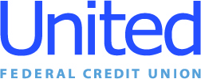

United Federal Credit Union – Press Release
February 23, 2021

Contact: Matt Orlando
Phone: (888) 982-1400 ext. 1473
Email: morlando@unitedfcu.com
United Federal Credit Union, 150 Hilltop Road, St. Joseph, MI 49085

United Federal Credit Union Hires
Two Mortgage Advisors to Serve Reno Community

RENO, Nev. – United Federal Credit Union (United) has named two new mortgage advisors to help serve the Reno community.

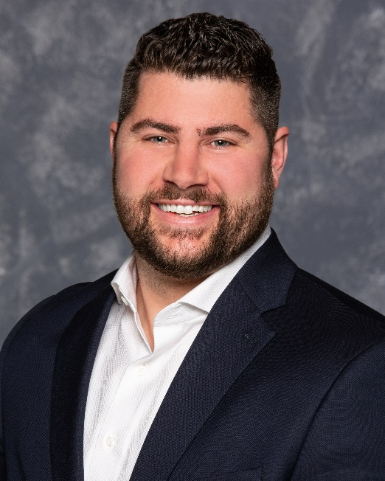

Aaron Henson, Mortgage Advisor, Summit Branch

Aaron Henson has been named Mortgage Advisor at United’s Summit branch at 13989 South Virginia Street. Henson will use his lending experience to assist credit union members with financial counseling and product awareness regarding real estate financing and generate quality mortgage loans.

Henson brings more than 12 years of mortgage lending experience to his new role. Previously, he served as Loan Officer at Greater Nevada Mortgage where he used his industry knowledge and service experience to help fellow Nevadans realize the dream of homeownership.

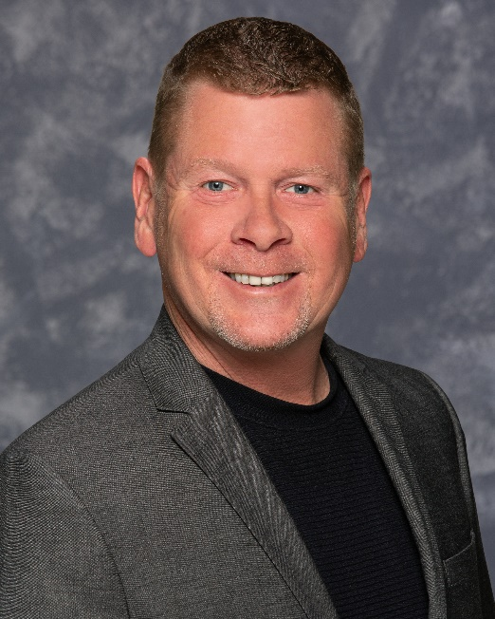

Michael Smith, Mortgage Advisor, Bible Way Branch

Michael Smith has been named Mortgage Advisor at United’s Bible Way branch at 1170 Bible Way. Smith will provide quality real estate lending expertise through financial counseling and product awareness to credit union members regarding their real estate financing needs and generate quality mortgage loans.

Smith brings 24 years of mortgage lending experience to his new role. Most recently, he was Regional Sales Manager at Greater Nevada Mortgage, where he paired his industry knowledge with a passion to help people find the right mortgage option for their new home.

In the community, both Henson and Smith will support United’s efforts in the Reno area with organizations including the Boys and Girls Club of Western Nevada and the American Red Cross Northern Nevada chapter.
____________
About United
United Federal Credit Union has served its Members since 1949 by helping them to build a sound financial future. United consists of more than 177,000 Member/owners worldwide and manages assets in excess of $3.3 billion. Its corporate offices and main branch are in St. Joseph, Mich., with additional branches in Arkansas, Indiana, Michigan, Nevada, North Carolina, and Ohio. Federally insured by NCUA. Equal opportunity lender. Equal housing lender. For more information visit www.unitedfcu.com

# # #

