United Federal Credit Union – Press Release
November 29, 2021

Contact: Diana Wake
Phone: (888) 982-1400 ext. 6891
Email: dwake@UnitedFCU.com
United Federal Credit Union, 150 Hilltop Road, St. Joseph, Michigan, 49085

United Federal Credit Union Names Kerry Lambert
Mortgage Advisor at Two Marion Branches
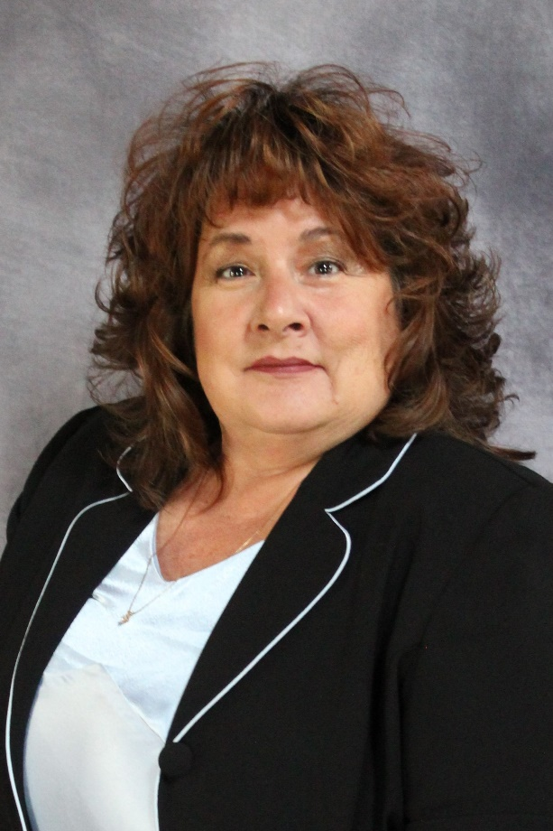
Kerry Lambert, Mortgage Advisor

MARION, Ohio. – United Federal Credit Union (United) is pleased to announce the appointment of Kerry Lambert as Mortgage Advisor at its Marion West and East branches.

Lambert will provide quality real estate lending expertise through financial counseling and product awareness to credit union members regarding their real estate financing needs and generate investment quality mortgage loans.

Lambert brings more than 30 years of financial experience to her new role. She has been involved in the Marion credit union industry since 1997 and joined United in 2003. Most recently, she was the Assistant Branch Manager at United’s Marion East branch. She pairs her industry knowledge with a passion to help people find the right mortgage option for their new home.

Lambert lives the credit union philosophy of ‘people helping people’ not only through member service, but also community involvement. She currently serves as an Ambassador for the Marion Area Chamber of Commerce, is Treasurer for Marion General Hospital TWIGI and TWIG Council. She is looking forward to continue working with United’s community partners in Marion including the Boys and Girls Club of Central Ohio and other non-profit organizations.
____________
About United
United Federal Credit Union has served its Members since 1949 by helping them to build a sound financial future. United consists of more than 180,000 Member/owners worldwide and manages assets in excess of $3.7 billion. Its corporate offices and main branch are in St. Joseph, Mich., with additional branches in Arkansas, Indiana, Michigan, Nevada, North Carolina, and Ohio. Federally insured by NCUA. Equal opportunity lender. Equal housing lender. For more information visit UnitedFCU.com

# # #

