United Federal Credit Union – Press Release
February 24, 2021

Contact: Matt Orlando
Phone: (888) 982-1400 ext. 1473
Email: morlando@unitedfcu.com
United Federal Credit Union, 150 Hilltop Road, St. Joseph, MI 49085

United Appoints Leiha Lamb to Business
Development Manager Role in Ohio
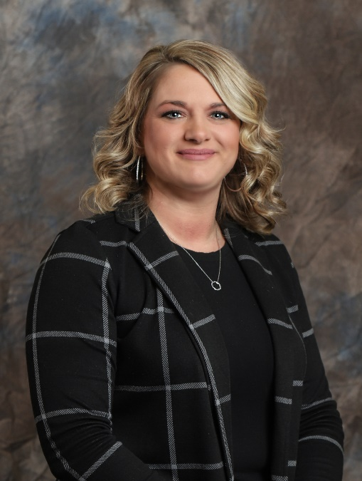
Leiha Lamb, Business Development Manager—Ohio Market
MARION, Ohio – United Federal Credit Union (United) has appointed Leiha Lamb as Business Development Manager in its Ohio market.
As Business Development Manager, Lamb will be responsible for results-driven business development while promoting Corporate Member engagement, business and consumer membership and loan growth and positive public relations. As part of this objective, she will identify and recruit new members in new and existing markets as well as develop and maintain existing corporate memberships.
Lamb will also lead Commercial lending in the Ohio market by providing financial counseling and product awareness to members, and by generating quality business loans in support of loan growth objectives.
Lamb’s career in the financial industry spans more than 20 years. She has been with United for 13 years serving as Assistant Branch Manager at the Marion West branch on Campbell Road.
In her time with the credit union, Lamb has developed relationships with Members based on outstanding support and service, and has helped the branch meet its goals by being a leader and mentor for branch staff, supporting efficient operational practices, and using sound judgment to make decisions in the best interest of the membership and the cooperative.
In the community, Lamb has served as treasurer for Restore the Glory Marion, and supports United’s community impact partnerships with the United Way of North Central Ohio, the Boys & Girls Club of Marion County, and other non-profit organizations.
___________
About United
United Federal Credit Union has served its Members since 1949 by helping them to build a sound financial future. United consists of more than 177,000 Member/owners worldwide and manages assets in excess of $3.3 billion. Its corporate offices and main branch are in St. Joseph, Mich., with additional branches in Arkansas, Indiana, Michigan, Nevada, North Carolina, and Ohio. Federally insured by NCUA. Equal opportunity lender. Equal housing lender. For more information visit www.unitedfcu.com

