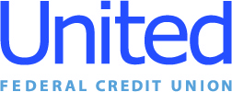

Press Release
June 9, 2021

Contact: Matt Orlando
Phone: (888) 982-1400 ext. 1473
Email: morlando@unitedfcu.com
United Federal Credit Union, 150 Hilltop Road, St. Joseph, MI 49085

United Federal Credit Union’s Four Newest Southwest Michigan Branches Enhance Member Experience with Expert Leadership

ST. JOSEPH, Mich. –United Federal Credit Union (United) has added four new branches in southwest Michigan as part of its recent acquisition last month of Edgewater Bank, and with it comes branch leadership appointments that keep familiar faces at familiar places. Taking the helm at each new Michigan branch—Downtown St. Joseph, Royalton, Bridgman, and Coloma—are the branch managers who held those roles prior to the acquisition.

Cara Burrows, Maryann Hurst, Sandi Kopach, and Debbie Mensinger will continue to lead their branch teams while adding a wealth of financial knowledge and customer service experience to United’s Michigan market. In their new roles, each Branch Manager will be responsible for maintaining the performance of the branch, providing leadership and supervision to staff, and enhancing the member experience by building relationships and offering personalized financial solutions for individuals and families.

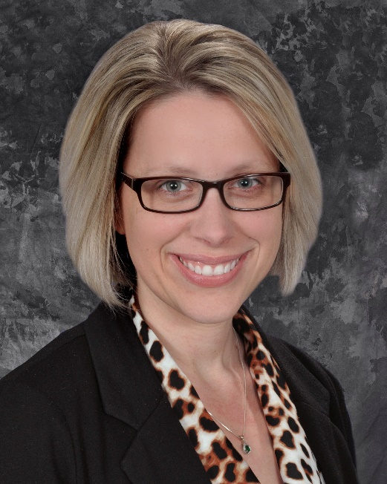

Cara Burrows, Branch Manager—Downtown St. Joseph

Cara Burrows has been appointed to the position of Branch Manager at the Downtown St. Joseph location. Burrows brings more than 17 years’ experience in the banking industry. She was with Edgewater Bank since 2010. Burrows became the Branch Manager of the St Joseph Office in January 2020 and will continue in that role at United. Prior to her Branch Manager position, Burrows was the Assistant Manager of the Coloma Banking Center, and also held the position of Operations Manager. Prior to starting with Edgewater Bank, she was a customer service representative with Fifth Third Bank.

In the community, Burrows is always willing to help out where needed. She owns and operates “Cupcakes by Cara”, which provides treats for many school and community events. Burrows is also an active volunteer for community fundraising events, and has worked with St. Joseph Today on several events. She plans on participating in more community activities as they resume this year and in the future.
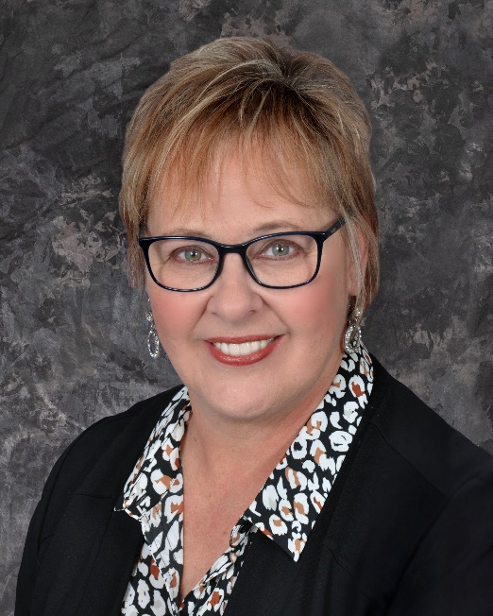

Mary Ann Hurst, Branch Manager—Coloma

Mary Ann Hurst has been appointed to the position of Branch Manager at the Coloma location. Hurst is a native of Southwest Michigan—attending New Buffalo High School and later Central Michigan University—and returned to the area in 2019 after moving to Kansas to raise her family and pursue her retail banking, mortgage lending, and credit union career.

She brings more than 30 years’ experience in the financial services industry, and even met her husband of 34 years while attending credit union-focused CUNA Mutual School in Madison, Wisconsin. Hurst returned to Berrien County to join the Edgewater team as Branch Manager in Coloma, where she will continue in that role as part of United. She plans on using her diverse financial experience to assist the credit union in achieving its mission by exceeding Member expectations through quality service and products.

In the community, Hurst currently volunteers with the Coloma Watervliet Chamber of Commerce and will support the credit union’s efforts in partnering with non-profit organizations like the United Way of Southwest Michigan, Girls on the Run, and the American Red Cross.
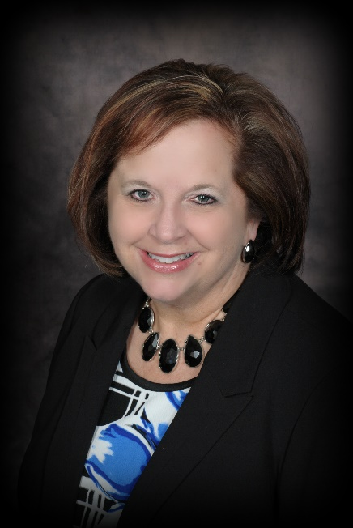

Sandi Kopach, Branch Manager—Royalton

Sandi Kopach has been appointed to the position of Branch Manager at the Royalton location.

Kopach brings more than 20 years’ banking experience, all within the St. Joseph/Berrien County market area. Prior to joining United, Kopach was a Branch Banking Officer with Edgewater Bank for six years and had previously worked at both Flagstar Bank and Fifth Third Bank. She values building relationships, offering exceptional customer service, and helping Members achieve their financial goals.

In the community, Kopach is an ambassador for the Southwest Michigan Regional Chamber, a volunteer and Board Member for Junior Achievement Berrien and Cass County, a board member for the Lakeshore Chamber of Commerce, a volunteer with United Way of Southwest Michigan, and a board member on select committees at Zion Church in St. Joseph.

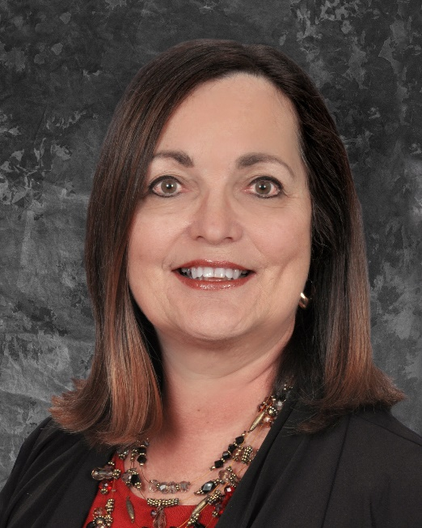

Debbie Mensinger, Branch Manager—Bridgman

Debbie Mensinger has been appointed to the position of Branch Manager at the Bridgman location. Mensinger’s experience in both the financial industry and customer service give her a practical and personal approach to branch leadership.

In her eight years at Edgewater Bank, she worked alongside teammates and management to evaluate the needs of their customers and provide the most relevant, individualized solutions available. This focus on customer satisfaction and financial responsibility earned Mensinger the role of Branch Manager in Bridgman in 2020. Her expertise in serving others is rooted in her nearly 20 years’ experience working in the Human Resources and Training departments at American Electric Power, as well as through owning and operating vacation rentals along Lake Michigan’s shore in the Harbor Country area.

In the community, Mensinger currently serves as a trustee for the Bridgman Foundation for Educational Excellence and volunteers with the Greater Bridgman Area Chamber of Commerce & Growth Alliance community festivals. She has also been a past member of the Berrien County ISD Parent Advisory Committee and the Michigan Alliance for Families Leadership Development Series.

“We are thrilled to welcome four of the best service-minded financial professionals in Southwest Michigan to Team United,” said Lisa Mahler, United’s Market Vice President in Michigan. “Cara, Mary Ann, Sandi, and Debbie not only bring years of experience to our new branches, they also have a passion for relating to the needs of each Member, and inspiring their teams to approach their roles in the same way. Being better together means combining our shared strengths to create a truly positive environment in our branches where we put the philosophy of ‘people helping people’ into action.”

____________

About United
United Federal Credit Union has served its Members since 1949 by helping them to build a sound financial future. United consists of more than 180,000 Member/owners worldwide and manages assets in excess of $3.6 billion. Its corporate offices and main branch are in St. Joseph, Mich., with additional branches in Arkansas, Indiana, Michigan, Nevada, North Carolina, and Ohio. Federally insured by NCUA. Equal opportunity lender. Equal housing lender. For more information visit www.unitedfcu.com

# # #

