United Federal Credit Union – Press Release
August 09, 2021

Contact: Diana Wake
Phone: (888) 982-1400 ext. 6891
Email: dwake@unitedfcu.com
United Federal Credit Union, 150 Hilltop Road, St. Joseph, Michigan, 49085

United Federal Credit Union Names Patrick Hunt
Mortgage Advisor in Hendersonville, North Carolina
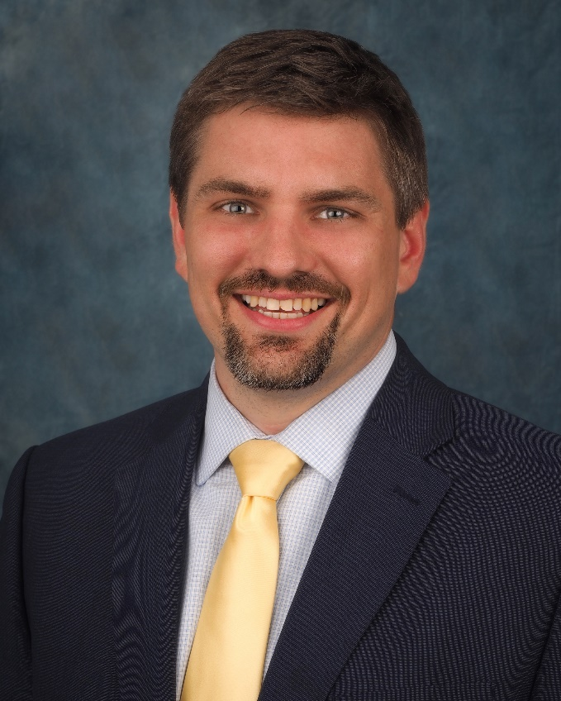
Patrick Hunt, Mortgage Advisor, Hendersonville South

HENDERSONVILLE, N.C. – United Federal Credit Union (United) is pleased to announce the appointment of Patrick Hunt as Mortgage Advisor at the Hendersonville South Branch at 203 Greenville Highway.

Hunt will provide quality real estate lending expertise through financial counseling and product awareness to credit union members regarding their real estate financing needs and generate investment quality mortgage loans.

He brings more than 20 years of financial and customer service experience to his new role. Most recently, Hunt was Branch Banking Team Lead at Truist Bank where he developed personal and business relationships by providing personalized solutions for his clients. He pairs his industry knowledge with a passion to help people find the right mortgage option for their new home.

Hunt is very active in the Hendersonville community. He is a member of Upward Christian Fellowship, Love & Action, & Compassion International, and is involved in Chain Breaker Cycles, an organization which provides bicycles, maintenance, and repair to those in need.

____________
About United
United Federal Credit Union has served its Members since 1949 by helping them to build a sound financial future. United consists of more than 180,000 Member/owners worldwide and manages assets in excess of $3.7 billion. Its corporate offices and main branch are in St. Joseph, Mich., with additional branches in Arkansas, Indiana, Michigan, Nevada, North Carolina, and Ohio. Federally insured by NCUA. Equal opportunity lender. Equal housing lender. For more information visit www.unitedfcu.com

# # #

