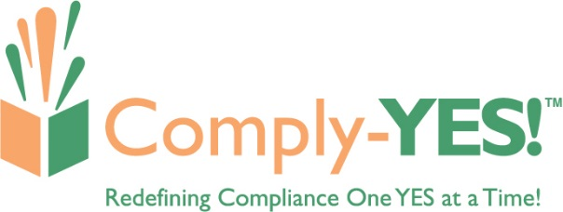

Contact: Steve Dedene, CEO
Comply-YES!
(248)221-1828
sdedene@comply-yes.com
www.comply-yes.com

Press Release: For Immediate Release
Comply-YES! Continues First Year Momentum: Adds Five Credit Unions and one CUSO in Q3 2021.

Warren, MI November 4- Comply-YES! continues its first-year momentum by establishing ally (client) relationships with the following credit unions and Credit Union Service Organization (CUSO):
- Caro Federal Credit Union, Columbia, SC, $109 Million in Assets
- Share One, Memphis, TN, Core Processing CUSO
- TLC Community Credit Union, Adrian, MI, $686 Million in Assets
- Astera Credit Union, Lansing, MI, $191 Million in Assets
- Alliance Catholic Credit Union, Farmington Hills, MI, $602 Million in Assets
- Federal Employees of Chippewa County Credit Union, Sault Sainte Marie, MI, $14 Million in Assets

With the addition of these six organizations, Comply-YES! has established ally relationships with 16 credit unions and one CUSO since officially launching on January 5, 2021. Comply-Yes! offers cost-effective compliance support and services. Allies can choose between an ala carte (one-time project-based engagement) or a full-service hourly model where Comply-YES! serves as an extension of the organization’s compliance department.
“We are ecstatic to have formed ally relationships with these credit unions and Credit Union Service Organization,” says Steve Dedene, CEO. “Navigating the winding road of compliance continues to burden credit unions and the credit union industry. Now more than ever, they need additional help or support to meet these ever-growing demands and expectations without increasing their FTE count. Comply-YES! delivers cost-effective, expert support, providing allies with a vacation from their compliance worries so they can focus on what matters most - serving their members!”

