United Federal Credit Union – Press Release
February 21, 2022

Contact: Diana Wake
Phone: (888) 982-1400 ext. 6891
Email: dwake@UnitedFCU.com
United Federal Credit Union, 150 Hilltop Road, St. Joseph, Michigan, 49085

United Federal Credit Union Names Senior Relationship Development Manager and Branch Manager in Michigan

ST. JOSEPH, Mich. – United Federal Credit Union (United) has named a new Senior Relationship Development Manager and Branch Manager in southwest Michigan.
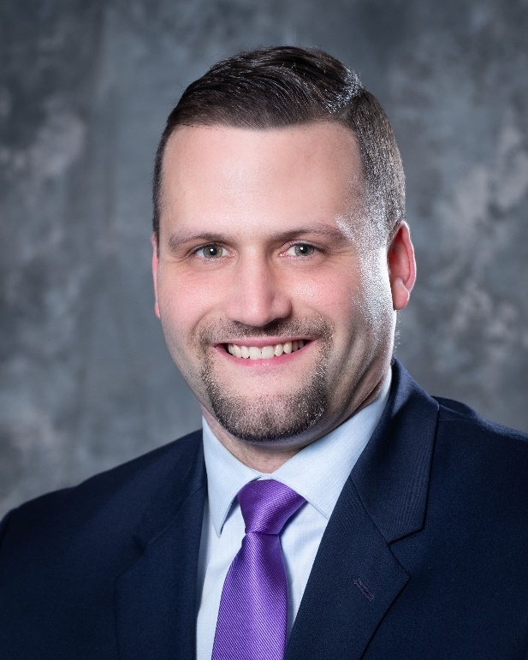
Joshua Pratt, Senior Relationship Development Manager, Southwest Michigan

United Federal Credit Union (United) has named Joshua Pratt Senior Relationship Development Manager in Southwest Michigan. Pratt is based at United’s branch at 2819 S. State St. in St. Joseph.

As Senior Relationship Development Manager, Pratt will be responsible for results-driven business development while promoting corporate member engagement, business and consumer membership and loan growth, and positive public relations. As part of this objective, Pratt will identify and recruit new members in new and existing markets as well as develop and maintain existing corporate memberships.

“I am excited to have the privilege and opportunity to not only help and assist our current United members, but also grow new relationships in our southwest Michigan communities,” said Pratt. “Community and relationships are extremely important in all aspects of business, and I am looking forward to making new connections in our communities.”

Pratt has more than 13 years of financial experience in the southwest Michigan banking industry. Most recently, he was the Financial Center Manager for Fifth Third Bank in St. Joseph.

Pratt lives the credit union philosophy of ‘people helping people’ not only through member service, but also community involvement. He is involved with the United Way of Southwest Michigan and is looking forward to working with United’s other partners in the community.

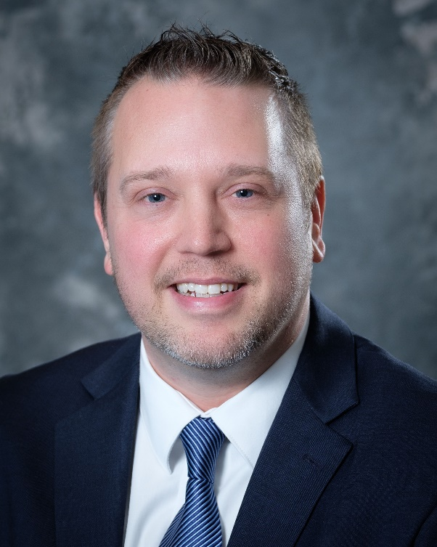
Justin Marshall, Branch Manager, Benton Harbor

United Federal Credit Union (United) has named Justin Marshall to the position of Branch Manager at its location at 724 E. Napier Ave. in Benton Harbor.

As Branch Manager, Marshall will be responsible for maintaining the performance of the branch, and providing leadership and supervision to staff.

“I am excited to lead our Benton Harbor team as we continue to enhance the financial lives of our members,” said Marshall. “When our members are successful, we are successful and so is our community.”

Marshall brings more than 18 years of financial experience to his new role. He has been with United since 2015. Prior to becoming branch manager, he was a Member Service Advisor.

Marshall graduated from Ohio University with a Bachelor of Science degree in Communication Systems Management. He looks forward to supporting United’s community impact efforts with organizations such as the Boys & Girls Club of Benton Harbor, and other local non-profit groups.

____________
About United
United Federal Credit Union has served its Members since 1949 by helping them to build a sound financial future. United consists of more than 191,000 Member/owners worldwide and manages assets in excess of $3.8 billion. Its corporate office and main branch are in St. Joseph, Mich., with additional branches in Arkansas, Indiana, Michigan, Nevada, North Carolina, and Ohio. Federally insured by NCUA. Equal opportunity lender. Equal housing lender. For more information visit UnitedFCU.com

# # #

