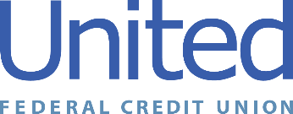

United Federal Credit Union – Press Release
December 13, 2021

Contact: Diana Wake
Phone: (888) 982-1400 ext. 6891
Email: dwake@UnitedFCU.com
United Federal Credit Union, 150 Hilltop Road, St. Joseph, Michigan, 49085

United Federal Credit Union Names Toni Polack
Mortgage Advisor in Northeast Nevada
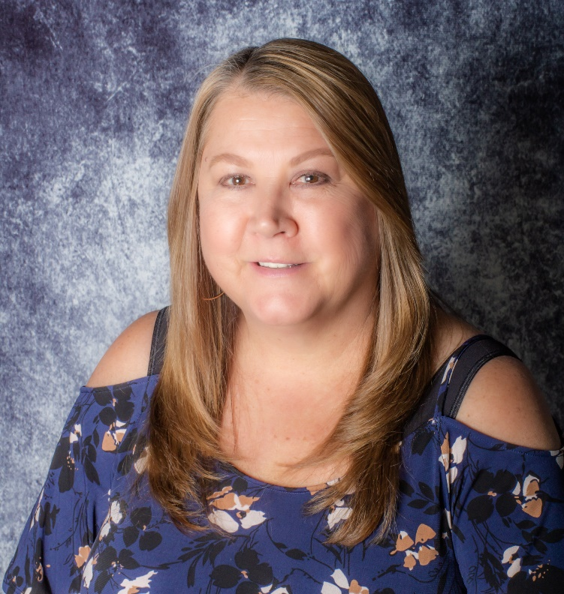
Toni Polack, Mortgage Advisor

ELKO, Nev. – United Federal Credit Union (United) is pleased to announce the appointment of Toni Polack as Mortgage Advisor in northeast Nevada. Polack is United’s mortgage lending expert in the Elko area and will make it more convenient for residents to have access to United’s products and services.

Polack will provide quality real estate lending expertise through financial counseling and product awareness to the community. She brings more than 21 years of mortgage and financial experience in the northeast region of Nevada to her new role. She pairs her industry knowledge with a passion to help people find the right mortgage option for their new home.

Polack lives the credit union philosophy of ‘people helping people’ not only through member service, but also community involvement. She has spent 17 years volunteering with the American Cancer Society Relay for Life. She also looks forward to supporting United’s community efforts.
____________
About United
United Federal Credit Union has served its Members since 1949 by helping them to build a sound financial future. United consists of more than 180,000 Member/owners worldwide and manages assets in excess of $3.7 billion. Its corporate offices and main branch are in St. Joseph, Mich., with additional branches in Arkansas, Indiana, Michigan, Nevada, North Carolina, and Ohio. Federally insured by NCUA. Equal opportunity lender. Equal housing lender. For more information visit UnitedFCU.com

# # #

