United Federal Credit Union – Press Release
July 29, 2021

Contact: Diana Wake
Phone: (888) 982-1400 ext. 6891
Email: dwake@unitedfcu.com
United Federal Credit Union, 150 Hilltop Road, St. Joseph, Michigan, 49085

United Federal Credit Union Names Canio Costanzo
Mortgage Advisor in Hendersonville, North Carolina
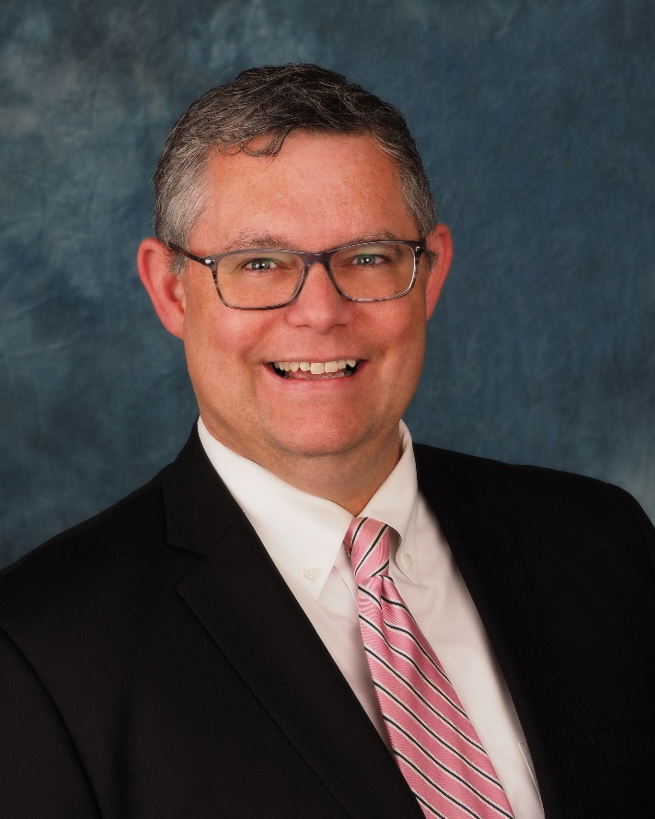
Canio Costanzo, Mortgage Advisor, Hendersonville South

HENDERSONVILLE, N.C. – United Federal Credit Union (United) is pleased to announce the appointment of Canio Costanzo as Mortgage Advisor at the Hendersonville South Branch at 203 Greenville Highway.

Costanzo will provide quality real estate lending expertise through financial counseling and product awareness to credit union members regarding their real estate financing needs and generate investment quality mortgage loans.

He brings more than 20 years of customer service experience to his new role. Most recently, Costanzo was a Customer Care Representative for Genova Diagnostics. He also spent five years as the Member Development Specialist with the Asheville Area Chamber of Commerce. He pairs his industry knowledge with a passion to help people find the right mortgage option for their new home.

Costanzo is passionate about helping his community. He created WNC Sports Network, an online sports broadcasting network which has broadcast more than 350 local high school sporting events since 2015. He has also volunteered with his local high school booster clubs.

____________
About United
United Federal Credit Union has served its Members since 1949 by helping them to build a sound financial future. United consists of more than 180,000 Member/owners worldwide and manages assets in excess of $3.7 billion. Its corporate offices and main branch are in St. Joseph, Mich., with additional branches in Arkansas, Indiana, Michigan, Nevada, North Carolina, and Ohio. Federally insured by NCUA. Equal opportunity lender. Equal housing lender. For more information visit www.unitedfcu.com

# # #

