

United Federal Credit Union – Press Release
July 28, 2021

Contact: Diana Wake
Phone: (888) 982-1400 ext. 6891
Email: dwake@unitedfcu.com
United Federal Credit Union, 150 Hilltop Road, St. Joseph, Michigan, 49085

United Federal Credit Union Names Kristine Cambunga
Branch Manager at S. McCarran Branch in Reno, Nevada
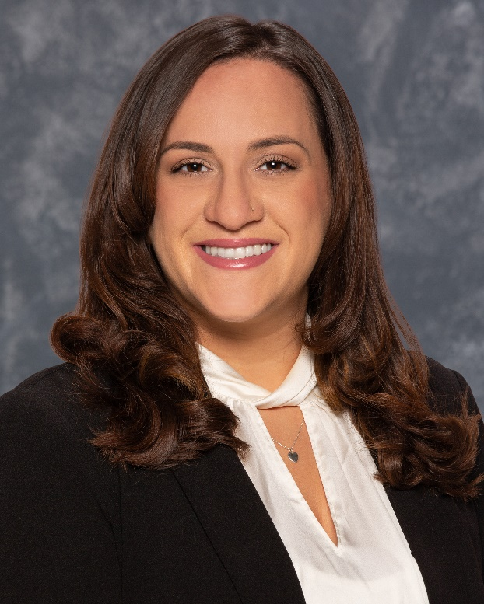
Kristine Cambunga, Branch Manager, South McCarran Branch

RENO, Nev. – United Federal Credit Union (United) has named Kristine Cambunga to the position of Branch Manager at its South McCarran branch in Reno at 4855 Kietzke Lane.

As Branch Manager, Cambunga will be responsible for maintaining the performance of the branch, and providing leadership and supervision to staff.

Cambunga brings seven years of banking and financial experience to her new role. Prior to her role with United, she was the Service Manager for Wells Fargo in Reno. She is pursuing a bachelor’s degree in criminal justice from the University of Nevada Reno and has an associate of liberal arts degree in criminal justice from Truckee Meadows Community College.

Cambunga lives the credit union philosophy of ‘people helping people’ not only through member service, but also community involvement. She is looking forward to working with United’s community partners in northwest Nevada including United Way of Northern Nevada and the Sierra, Girls on the Run Sierras and the Boys and Girls Club of Truckee Meadows.

____________
About United
United Federal Credit Union has served its Members since 1949 by helping them to build a sound financial future. United consists of more than 180,000 Member/owners worldwide and manages assets in excess of $3.7 billion. Its corporate offices and main branch are in St. Joseph, Mich., with additional branches in Arkansas, Indiana, Michigan, Nevada, North Carolina, and Ohio. Federally insured by NCUA. Equal opportunity lender. Equal housing lender. For more information visit www.unitedfcu.com

# # #

