United Federal Credit Union – Press Release
October 20, 2021

Contact: Diana Wake
Phone: (888) 982-1400 ext. 6891
Email: dwake@UnitedFCU.com
United Federal Credit Union, 150 Hilltop Road, St. Joseph, Michigan, 49085

Speaker Series Partnership Brings Diversity, Equity, and Inclusion Discussion to St. Joseph Public Schools

ST. JOSEPH, Mich. – The first speaker series presented in partnership with St. Joseph Public Schools, St. Joseph Public Schools Foundation, and United Federal Credit Union (United) happened on Monday, October 18, 2021 at St. Joseph High School.

"Bringing the inspirational Dr. Brown back to SJPS for our staff is a gift. The partnership with our SJPS Foundation and United Federal Credit Union allows us to share this gift with our community at large,” said St. Joseph Public Schools Superintendent, Jennifer Fee. “One important component of our strategic plan is to leverage the power of community partnerships. We know, when our District, our Foundation, and our community partners work together to support common knowledge and understanding, everyone grows. Bringing a nationally renowned speaker, such as Dr. Brown to our wider community will serve to strengthen, support, and even transform our larger community in a common goal.”

Students, educators, and community members attended Dr. Adolph Brown’s discussion “Don’t Judge a Book by Its Cover: Diversity, Equity, and Inclusion in Action.” The three 90-minute sessions explored the prejudice of making decisions solely based on outward appearance and their cost on meaningful encounters

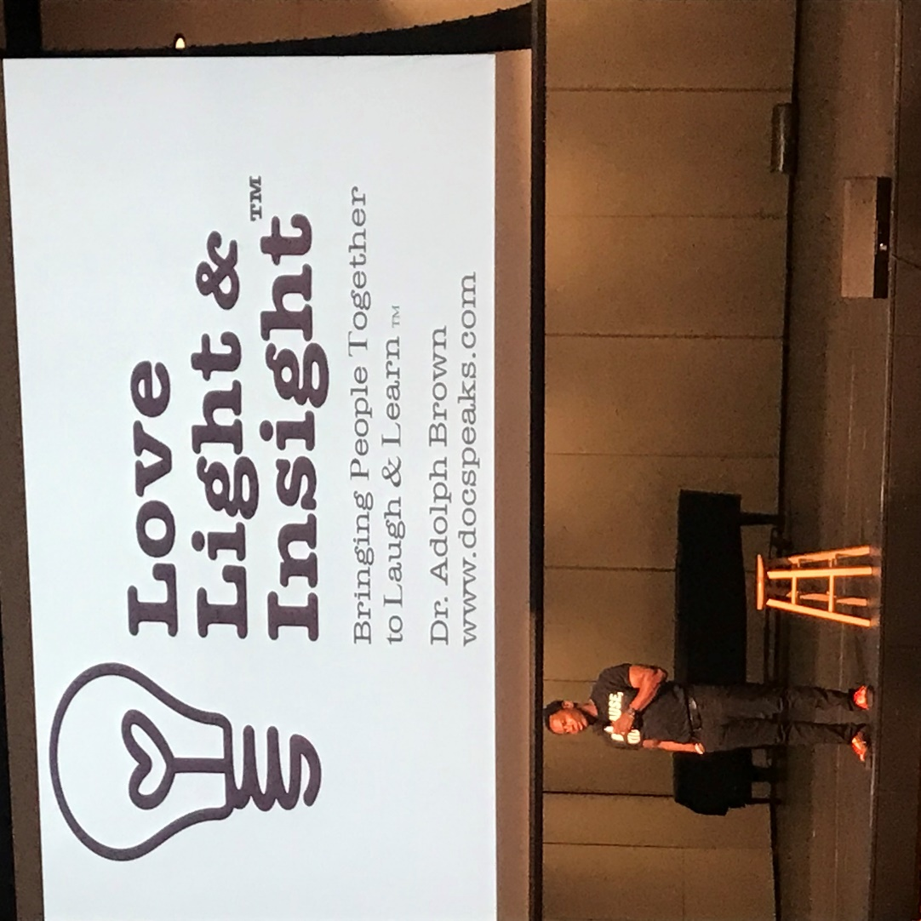
Dr. Brown speaks at St. Joseph High School

“We are very grateful for the opportunity to partner with St. Joseph Public Schools and the St. Joseph Public Schools Community Foundation to bring speakers like Dr. Brown to our community,” said Rick Dyer, United Community President. “At United, we are dedicated to creating a place where employees feel valued, trusted and included. Dr. Brown’s message of exploring prejudice of making decisions solely based on outward appearance and the impact of those decisions is such an important message for not only Team United to learn about and be able to identify, but it is a valuable lesson for our entire community.”

____________
About United
United Federal Credit Union has served its Members since 1949 by helping them to build a sound financial future. United consists of more than 180,000 Member/owners worldwide and manages assets in excess of $3.7 billion. Its corporate offices and main branch are in St. Joseph, Mich., with additional branches in Arkansas, Indiana, Michigan, Nevada, North Carolina, and Ohio. Federally insured by NCUA. Equal opportunity lender. Equal housing lender. For more information visit UnitedFCU.com

# # #

