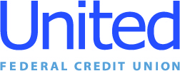

**United Federal Credit Union – Press Release**

October 11, 2021

Contact: Diana Wake

Phone: (888) 982-1400 ext. 6891

Email: [dwake@UnitedFCU.com](mailto:dwake@UnitedFCU.com)

United Federal Credit Union, 150 Hilltop Rd., St. Joseph, MI 49085

**United Federal Credit Union Employee Campaign   
Raises More Than $47,000 to Benefit the United Way**

**ST. JOSEPH, Mich. –** United Federal Credit Union’s annual United Way employee fundraising campaign set a new internal record netting $23,547 in individual pledges. The credit union added to that total with a dollar-for-dollar match bringing the total United Way donation to $47,094.

“I am so proud of our employees for their generosity and making sure the members of our communities are taken care of,” said United Federal Credit Union President/CEO Terry O’Rourke. “It is inspiring to see their commitment to community—from volunteering time and talent to sharing financial resources with others. Team United has once again proven they can always be counted on to deliver when partners like United Way call upon us to help.”

The 2021 employee fundraising campaign leveraged the theme “We Were Built for This” and rallied employees around the greatest needs that each regional United Way chapter was facing. People helping people is part of the credit union philosophy, and it has taken on a more significant meaning during 2020-2021 as members and communities have faced a number of challenges related to the COVID-19 pandemic.

“Workplace campaigns are United Way’s primary means of fundraising, and it drives everything we do. The success of United Federal Credit Union’s campaign contributes significantly to the overall success of United Way,” said Anna Murphy, President and CEO of United Way of Southwest Michigan. “Our partnership with United is crucial to our work improving the health, education, and financial stability of every person in every community we serve.”

The United Way of Southwest Michigan also honored United Federal Credit Union’s commitment to the community with its “Volunteer United Business Partner Impact Award”. The award recognizes “a corporation, company, or business from Berrien, Cass or Van Buren County that has fostered an environment of volunteerism within their organization, and supports the work of United Way of Southwest Michigan’s Impact Areas: Education, Health, Financial Stability, and/or Basic Needs.”

As part of the award, United Federal Credit Union received $1,000 to donate to a local non-profit organization and will give the donation to North Berrien Senior Center in Coloma.

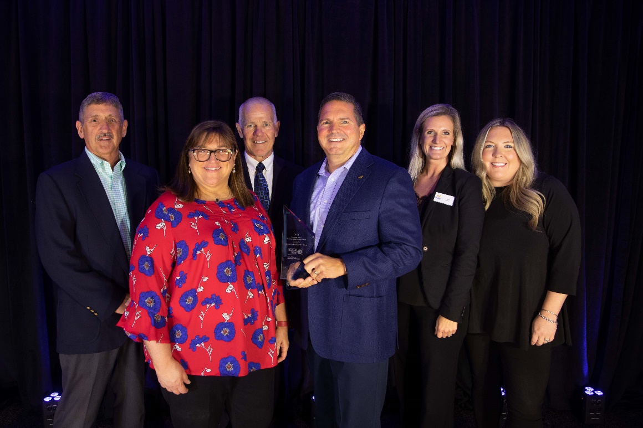

*Members of Team United with Anna Murphy (second from left), President*

*and CEO of United Way of Southwest Michigan, after receiving the*

*Volunteer United Business Partner Impact Award*

**____________**

**About United**

United Federal Credit Union has served its Members since 1949 by helping them to build a sound financial future. United consists of more than 180,000 Member/owners worldwide and manages assets in excess of $3.7 billion. Its corporate offices and main branch are in St. Joseph, Mich., with additional branches in Arkansas, Indiana, Michigan, Nevada, North Carolina, and Ohio. Federally insured by NCUA. Equal opportunity lender. Equal housing lender. For more information visit [www.unitedfcu.com](http://www.unitedfcu.com)

# # #