United Federal Credit Union – Press Release
October 12, 2021

Contact: Diana Wake
Phone: (888) 982-1400 ext. 6891
Email: dwake@UnitedFCU.com
United Federal Credit Union, 150 Hilltop Road, St. Joseph, Michigan, 49085

Two United Federal Credit Union Employees Named to
‘40 Under 40’ List in Southwest Michigan

ST. JOSEPH, Mich. – Two members of United Federal Credit Union (United) have been selected for Moody on the Market’s 40 Under 40 for 2021 list. Radio personality, Pat Moody, announced Tim Dyer and Alex Grumbine’s designations on MoodyontheMarket.com and 94.9 WSJM in early October 2021.

Alex Grumbine, Moody on the Market’s 40 Under 40 2021

Grumbine has been with United since 2018. He is a Commercial Lending Officer and helps businesses grow and develop in southwest Michigan.

“I am extremely honored to be named to the “40 Under 40” list with the support of the southwest Michigan community,” Grumbine said of his nomination. “Our community is filled with so many talented and strong leaders that I’m grateful to be recognized. I’ve really enjoyed learning more about the other nominees over the years and their stories have encouraged me to also drive impact in the community.”

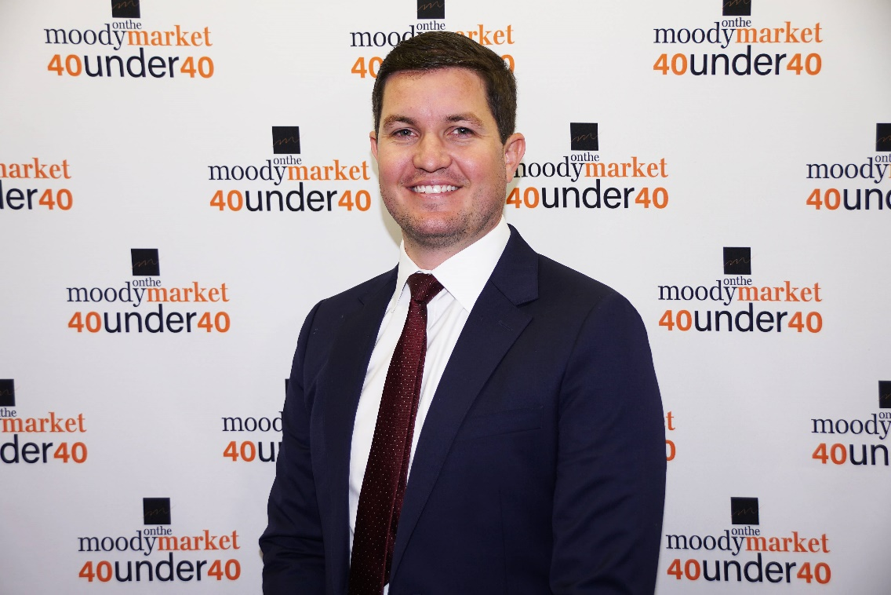
Tim Dyer, Moody on the Market’s 40 Under 40 2021

Dyer has worked for United since May 2021 as the Commercial Lending Group Manager. He played an integral role transitioning the Edgewater Bank commercial lending team to United. Dyer was with Edgewater Bank as the Vice President of Commercial Lending for more than five years.

“The impressive members of the prior classes have set high expectations,” said Dyer when asked about his nomination. “I plan to continue that tradition by doing my part to relentlessly improve our community for future generations.”

Both Dyer and Grumbine actively practice the credit union philosophy of ‘people helping people’ by being dedicated to making southwest Michigan a better place to work and live, and by making a difference in the community. As part of Team United, they look to grow and improve the business community through their professional efforts.
____________
About United
United Federal Credit Union has served its Members since 1949 by helping them to build a sound financial future. United consists of more than 180,000 Member/owners worldwide and manages assets in excess of $3.7 billion. Its corporate offices and main branch are in St. Joseph, Mich., with additional branches in Arkansas, Indiana, Michigan, Nevada, North Carolina, and Ohio. Federally insured by NCUA. Equal opportunity lender. Equal housing lender. For more information visit UnitedFCU.com

# # #

