

**United Federal Credit Union – Press Release**

January 21, 2022

Contact: Diana Wake

Phone: (888) 982-1400 ext. 6891

Email: [dwake@UnitedFCU.com](mailto:dwake@UnitedFCU.com)

United Federal Credit Union, 150 Hilltop Road, St. Joseph, Michigan, 49085

**United Federal Credit Union Creates District Manager Positions to Assist in Michigan and Indiana Markets**

**ST. JOSEPH, Mich. –** United Federal Credit Union (United) is pleased to announce the creation of the role of District Manager in both Michigan and Indiana. Jodie Kitchell and Carla Fazio-King have been promoted to the newly created roles to support United’s large markets in both states.

United’s District Managers will provide leadership and support to branch managers, as well as oversee the branches in their district. They will also be responsible for maintaining and growing new consumer and business members.

"We are happy to not only have Jodie and Carla continue to lead our regional teams, but also structure ourselves in a way that best serves our Members,” said Lee Beason, Regional Vice President. “By creating these District Manager positions, our teams in Michigan and Indiana will have dedicated leadership that focuses on specific needs impacting those communities, allowing us to deliver a more personalized experience to Members and community partners."

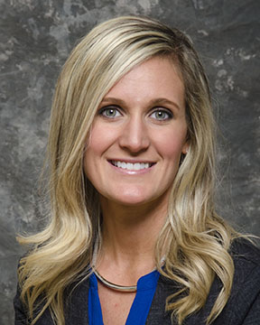

*Jodie Kitchell, District Manager, Midwest Region*

Kitchell will now lead ten Michigan branches: Benton Harbor, Bridgman, Coloma, Holland North, Holland South, Niles South, Downtown St. Joseph, State Street in St. Joseph, Stevensville, and Royalton.

Kitchell has been with United for more than 10 years. Most recently, she was the Regional Market Development Manager for North Berrien County.

“This new role allows me to work very closely with our communities to not only help them reach their goals, but United’s as well,” said Kitchell. “Our Members are our number one priority, and the creation of the District Manager role is another way to help impact our communities in extraordinary ways. I look forward to having the opportunity to positively impact southwest Michigan in the years to come.”

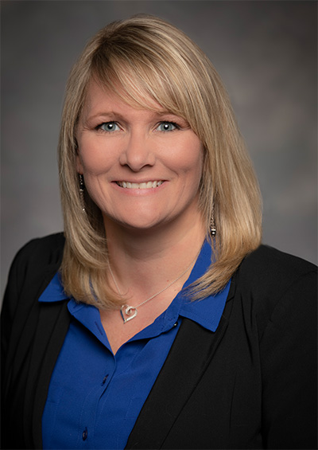

*Carla Fazio-King, District Manager, Indiana Region*

Fazio-King will now lead five Indiana branches and three Michigan branches: Bremen Highway and Edison Lakes branches in Mishawaka, Griffith branch and Ireland Road branch in South Bend, Toscana Park in Granger, Niles North, Berrien Springs, and Buchanan.

Fazio-King has been with United since 2018. Most recently, she was the Regional Market Development Manager supporting branches in Indiana.

“This new opportunity allows me to work closely with our retail teams in Indiana and South Berrien County in Michigan, and to help provide amazing personalized service to our Members,” said Fazio-King. “I am excited to take on this new role and look forward to continuing United’s community involvement and making a positive impact in the communities where we work and live.”

As it continues to find ways to offer exceptional service to its Members, United has also revised the title of the role of Market Vice President to Regional Vice President. The role will continue to develop and execute United’s integrated marketplace business and marketing plans to drive sales, service and business development initiatives to continue market growth. United’s three Regional Vice Presidents are Stephanie Riffle in Arkansas, Meredith Williams in Nevada, and Lee Beason in Indiana, Michigan, North Carolina, and Ohio.

**____________**

**About United**

United Federal Credit Union has served its Members since 1949 by helping them to build a sound financial future. United consists of more than 191,000 Member/owners worldwide and manages assets in excess of $3.9 billion. Its corporate offices and main branch are in St. Joseph, Mich., with additional branches in Arkansas, Indiana, Michigan, Nevada, North Carolina, and Ohio. Federally insured by NCUA. Equal opportunity lender. Equal housing lender. For more information visit [UnitedFCU.com](http://www.unitedfcu.com)

# # #