United Federal Credit Union – Press Release
December 14, 2021

Contact: Diana Wake
Phone: (888) 982-1400 ext. 6891
Email: dwake@UnitedFCU.com
United Federal Credit Union, 150 Hilltop Road, St. Joseph, Michigan, 49085

United Partners with The Storehouse to Provide Gifts for
104 Children this Holiday Season
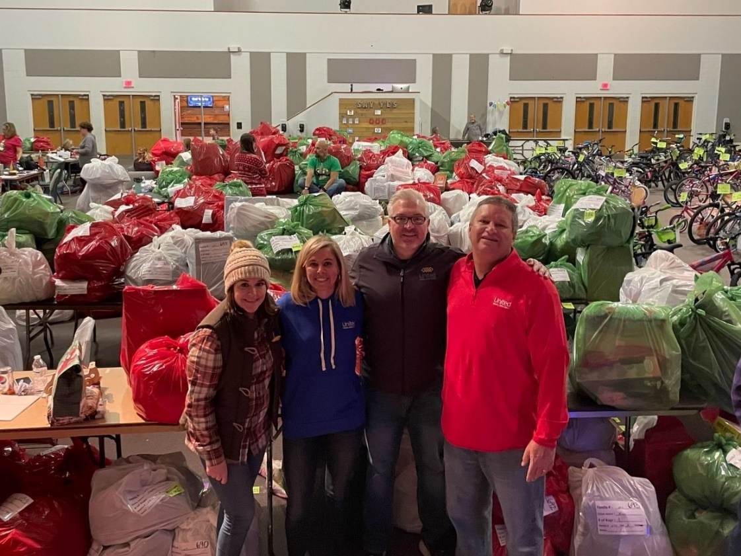
L to R: Celeste Robbins, United Field Operations Coordinator; Meredith Miller, United Mortgage Advisor; Vince McMahan, United Commercial Loan Officer;
David Crow, United Business Development Manager

HENDERSONVILLE, N.C. – United Federal Credit Union (United) employees once again partnered with The Storehouse to purchase gifts for 104 children in Henderson County, North Carolina, as part of The Storehouse’s Blessings in Boxes community initiative.

The Storehouse is a non-profit organization based in Hendersonville. It provides food and hygiene products to people with limited financial resources and, often, limited life skills. Its annual Blessings in Boxes program provides clothing and toys to children as well as coats, hats, gloves and blankets to anyone in need during the holiday season.

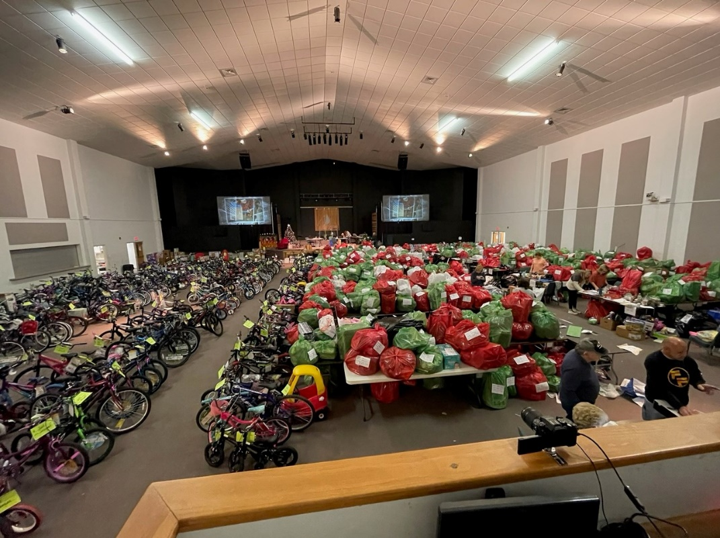
Toys, bicycles and clothing ready to be donated

United donated more than $10,000 to help purchase gifts and support volunteers as part of its partnership with The Storehouse to support the 2021 Blessings in Boxes program. Overall, the program was able to serve more than 1,800 children.

“The Storehouse is an inspiration to the entire community and the Blessings in Boxes program is one that United employees look forward to supporting every year,” said United Business Development Manager, David Crow. “We hope our continued partnership is able to spread a little holiday cheer in what has been another tough year.”

____________
About United
United Federal Credit Union has served its Members since 1949 by helping them to build a sound financial future. United consists of more than 180,000 Member/owners worldwide and manages assets in excess of $3.7 billion. Its corporate offices and main branch are in St. Joseph, Mich., with additional branches in Arkansas, Indiana, Michigan, Nevada, North Carolina, and Ohio. Federally insured by NCUA. Equal opportunity lender. Equal housing lender. For more information visit UnitedFCU.com

# # #

