United Federal Credit Union – Press Release
October 4, 2021

Contact: Diana Wake
Phone: (888) 982-1400 ext. 6891
Email: dwake@UnitedFCU.com
United Federal Credit Union, 150 Hilltop Road, St. Joseph, Michigan, 49085

United Federal Credit Union Names Evan McCullough
Director of Loss Prevention and Assets Recovery
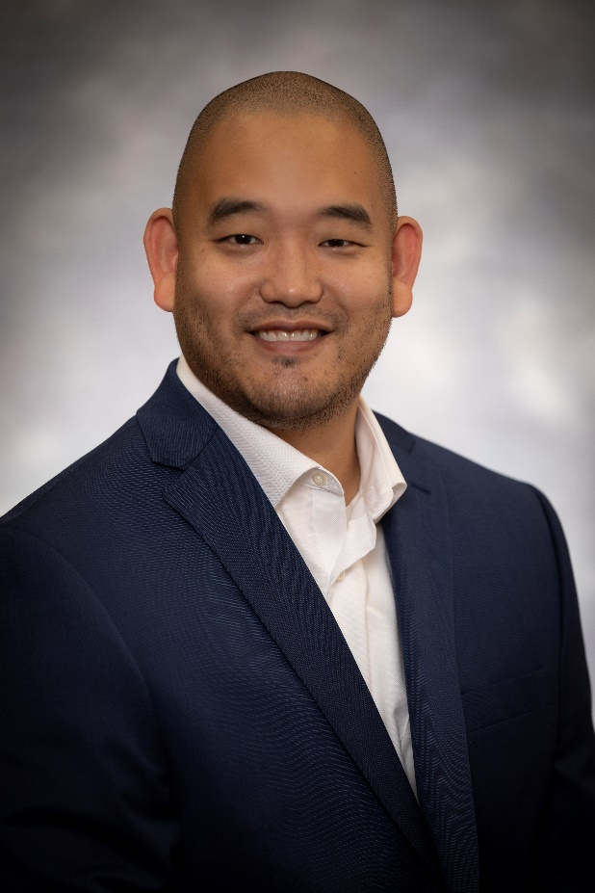
Evan McCullough, Director of Loss Prevention and Assets Recovery

ST. JOSEPH, Mich. – United Federal Credit Union has promoted Evan McCullough to the position of Director of Loss Prevention and Assets Recovery based in Niles, Michigan.

McCullough has been with United for more than eight years. He began his tenure with the credit union as a Member Service Advisor. Most recently, he was the Special Assets Manager. In that position, McCullough was responsible for mitigating losses to the credit union’s assets.

In his new role with United, McCullough will provide vision, leadership, and coaching to United’s foreclosure, fraud, bankruptcy, repossession, collections, and loss mitigation and recovery teams. He will also manage a portfolio of assigned commercial loans, and will be responsible for monitoring and analyzing economic trends.

McCullough holds a bachelor of business administration degree from Ferris State University. He also looks forward to continue supporting United’s community impact efforts with organizations such as the United Way of Southwest Michigan, and other local non-profit groups.

____________
About United
United Federal Credit Union has served its Members since 1949 by helping them to build a sound financial future. United consists of more than 180,000 Member/owners worldwide and manages assets in excess of $3.7 billion. Its corporate offices and main branch are in St. Joseph, Mich., with additional branches in Arkansas, Indiana, Michigan, Nevada, North Carolina, and Ohio. Federally insured by NCUA. Equal opportunity lender. Equal housing lender. For more information visit UnitedFCU.com

# # #

