United Federal Credit Union – Press Release
August 16, 2021

Contact: Diana Wake
Phone: (888) 982-1400 ext. 6891
Email: dwake@unitedfcu.com
United Federal Credit Union, 150 Hilltop Road, St. Joseph, Michigan, 49085

United Federal Credit Union Names Jessica Parmele
Branch Manager at Spanish Springs Branch in Sparks, Nevada
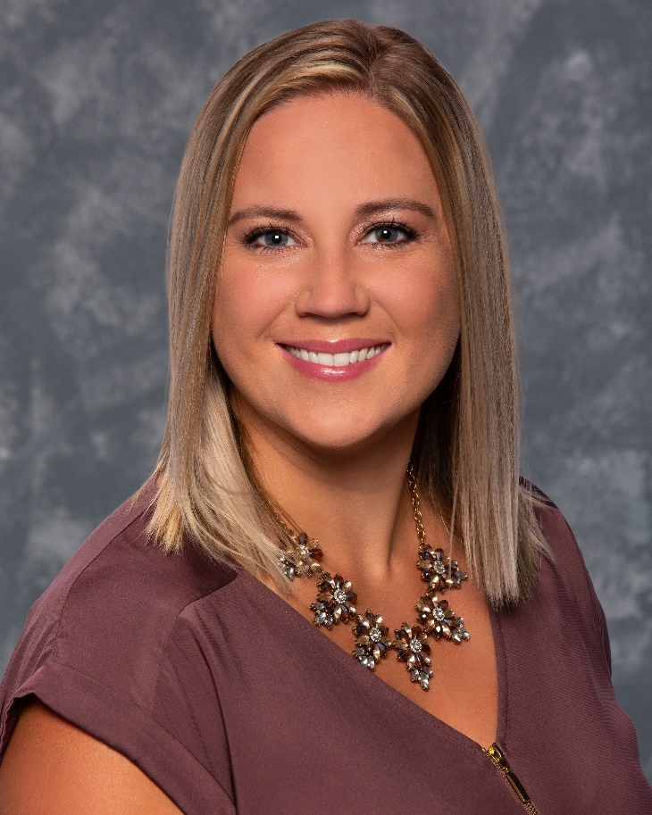
Jessica Parmele, Branch Manager, Spanish Springs Branch

SPARKS, Nev. – United Federal Credit Union (United) has named Jessica Parmele to the position of Branch Manager at its Spanish Springs branch in Sparks at 2432 Wingfield Hills Road.

As Branch Manager, Parmele will be responsible for maintaining the performance of the branch, and providing leadership and supervision to staff.

Parmele brings more than 15 years of banking and financial experience to her new role. Prior to her role with United, she was a Manager for Umpqua Bank. Parmele has an associate of liberal arts and associate of general studies degree from Sierra College.

Parmele lives the credit union philosophy of ‘people helping people’ not only through member service, but also community involvement. She is looking forward to working with United’s community partners in northwest Nevada including United Way of Northern Nevada and the Sierra, Girls on the Run Sierras and the Boys and Girls Club of Truckee Meadows.

____________
About United
United Federal Credit Union has served its Members since 1949 by helping them to build a sound financial future. United consists of more than 180,000 Member/owners worldwide and manages assets in excess of $3.7 billion. Its corporate offices and main branch are in St. Joseph, Mich., with additional branches in Arkansas, Indiana, Michigan, Nevada, North Carolina, and Ohio. Federally insured by NCUA. Equal opportunity lender. Equal housing lender. For more information visit www.unitedfcu.com

# # #

